AUTOMATION AND CONTROL OF TECHNOLOGICAL PROCESSES AND PRODUCTIONS
Drapak K.A., Krylov E.G., Kapitanov A.V.
Method for multi-criteria assessment of regasification terminals efficiency

Afonina I.V., Glubokov A.V.
Selection of a method for measuring the linear size of a cylindrical part by the coordinate method

Ponomarev K.S., Feofanov A.N., Grishina T.G.
An automated system of generating and providing verification data of measuring instruments as
a tool for improving the efficiency of the organization’s functioning

Karlov A.G.
Theoretical and methodological basis, functional capabilities of the Solving Mill 2.0 software product in the creation of innovative technologies and technical systems for industrial automation

TECHNOLOGY AND EQUIPMENT OF MECHANICAL AND PHYSICAL- TECHNICAL PROCESSING
Fomin E.V., Snegireva K.K.
Planning an experimental study cutting of alpha titanium alloys

TECHNOLOGY OF MACHINE BUILDING
Zhukov S.V., Sterlin A.Y., Suminov I.V.
Technology of polymer-metal oxide composites for adaptive protection against setting
and jamming during friction on the example of antifriction layers obtained by plasmaelectrolytic treatment of cylinders of a modulator of high-energy acoustic radiation

TECHNOLOGIES AND MACHINES OF PROCESSING BY PRESSURE
Dmitriev A.M., Korobova N.V.
Design of dies for forming high density hollow axisymmetric powder parts

ROBOTS, MECHATRONICS AND ROBOTIC SYSTEMS
Panfilov P.V.
Module for rapid prototyping of mechatronic device control

Veltishchev V.V., Aladysheva E.I.
Development and implementation of software for analyzing the spatial position of the cable line of the hybrid underwater robotic system

Gavrilina E.A., Chestnov V.N.
Synthesis of an Attitude Control System for Highly Maneuverable Underwater Vehicle Using H-infinity Approach

METHODS OF ECONOMICS
Moskvicheva N.V., Burdin S.S., Filina I.I.
Methodological approach to multi-level assessment of strategic risk of life cycle management of high-tech aircraft products

УДК 681.5:622.276
Drapak K.A., Krylov E.G., Kapitanov A. V.

Method for multi-criteria assessment of regasification terminals efficiency

The general production indicators of gas production at LNG terminals of PJSC «NK
«Rosneft» are considered. The main groups of criteria are identified, which are necessary to identify risks during the operation of automated process equipment of LNG terminals. An algorithm for multi-criteria assessment of the effectiveness of projects for the modernization of LNG terminals has been developed.
Key words: LNG terminal, reliability, identification, risk, optimality criterion.

An analysis of the annual performance indicators of Rosneft revealed a decrease in natural gas and oil production, as well as the commissioning of new wells in 2020 compared to 2019 and 2018 (Table 1). This decrease in oil and gas production occurred against the background of the OPEC+ agreement.
Table 1. Production indicators of Rosneft gas production for 2018-2020 [1]

Indicator | 2018 | 2019 | 2020
Oil and gas condensate production, million cubic  meters | 2,9 | 2,6 | -
Gas production, billion cubic meters | 67,3 | 67,0 | 62,8
Commissioning of new wells, thousand units | 3,484 | 2,9 | 2,6
Production of liquid hydrocarbons, million tons | 230,2 | 230,2 | 204,5
Proven gas reserves according to PRMS  classification, billion cubic meters | 2420 | 2452 | 2106
In this regard, the construction and modernization of terminals for storage and transportation of liquefied natural gas (LNG terminals) seems to be a promising direction of development in the field of energy. Regasification of natural gas at LNG terminals is a technological process in which various types of complex and expensive automatic and automated equipment are used. The LNG terminal is a special regasification complex consisting of a berth, a discharge jetty, storage tanks, an evaporation system, evaporation gas treatment plants from tanks, a metering unit and process units [2].
During the construction and operation of the LNG terminal, a quantitative assessment of hazards is necessary, which will allow taking into account adjacent or responsible port facilities and civilian areas, as well as geographical conditions of port territories and resort areas in order

to reduce the likelihood of accidents and man-made disasters. To achieve the required level of reliability of automated equipment, it is necessary to perform a complex of special works. It includes activities aimed at solving the following tasks [3]:
- selection of failure criteria for functions of each type performed in different modes of operation of the facility;
- determination of the composition (nomenclature) of indicators of reliability of system functions;
- establishment of requirements for the necessary values of indicators of reliability of functions;
- obtaining design (calculated) estimates of the reliability level of the system;
- adoption and implementation of decisions on the application of special reliability improvement measures in the system (if necessary);
- obtaining experimental estimates of system reliability indicators (if necessary).
Assessment of reliability in the presence of risks is mandatory when implementing automated systems at gas processing plants.
When identifying the risks of a specific LNG terminal modernization project, it is advisable to use criteria that follow directly from the goals, strategy and objectives of modernization. At the same time, modernization projects that receive high evaluation from the standpoint of some goals, strategies and tasks may not receive it from the point of view of other performance criteria [4].
Groups of performance criteria were identified, which are shown in Table 2.

Table 2. Main groups of performance criteria

General criteria | Particular criteria
Technological K1 | - Gas processing volume  - Weak technical equipment  - Nelson complexity index  - Technological level of production
Economic K2 | - Decreased supply growth in the market  - Ruble devaluation  - Decrease in cash balances, debts  - Rising dollar and euro
Environmental K3 | - Emissions of carbon dioxide CO2 into the atmosphere  - Greenhouse gas emissions, wastewater discharges into the

water area
To solve the problem of modernization of gas terminals, it is necessary to take into account the generalized criterion for the complex of the above parameters. The method of multi- criteria assessments allows us to take into account those conditions and quality indicators that will further contribute to finding an effective solution to the problem.
Figure 1 shows a diagram of changes in the values of the performance criteria of Rosneft PJSC in the field of LNG terminal modernization for 2018-2020. The algorithm for multi-criteria evaluation of the effectiveness of LNG terminal modernization projects is presented in Figure 2.
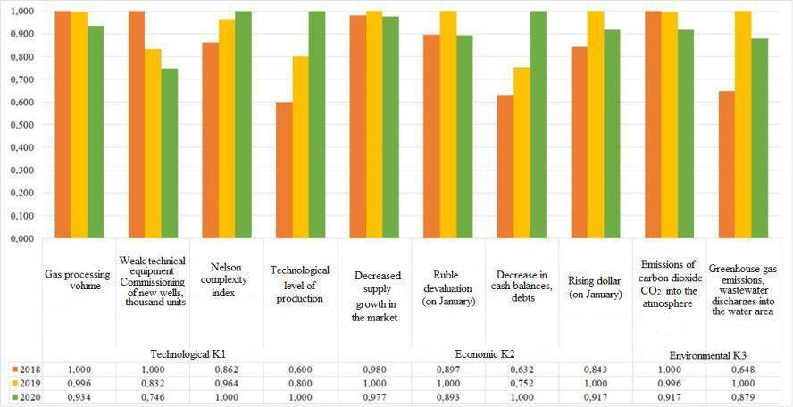
Fig. 1. Diagram of changes in the values of performance criteria

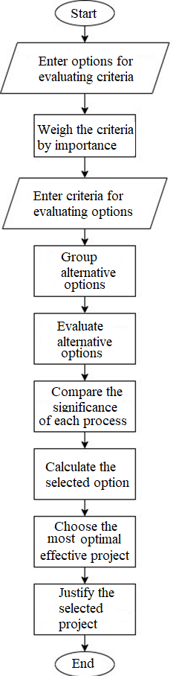
Fig. 2. Algorithm for multi-criteria evaluation of the effectiveness of modernization projects When performing a multi-criteria assessment, it is assumed to build a mathematical
model of the object of study. A formal description of possible options and their consequences is carried out in order to obtain the best alternative. The importance of the criteria is determined based on the responses of experts and the decision-maker, depending on the specific situation. Numerical values are set for each of the criteria used to compare vector estimates, which are ordered by preference. If some value of the criterion for the option under consideration is greater than another, then it is preferable. In addition to the ratings, the positivity and negativity of the criteria are set. For example, the larger the volume of gas processing billion cubic meters, the

better. The criteria may have different significance and are indicated as a percentage, where 100% is absolute significance.
Based on the analysis of a number of optimality criteria, an additive criterion was selected, the objective function of which is defined as follows (1):
 | n  Ai = ∑di ⋅ ni ,  i =1 | (1)

where
di is a weighting coefficient that determines the degree of preference for the i-th

indicator compared to others; ni
is the normalized value of the indicator of the i-th criterion.

To calculate the additive criterion, it is necessary to bring the values to a normalized form. The maximum value is equal to one, and the remaining values range from zero to one. Next, the positivity and negativity of the criterion are taken into account.
The results of calculations of the objective function of the additive criterion of Rosneft's activities in the field of modernization of LNG terminals for 2018-2020 are shown in Table 3. The higher the absolute value of the criterion, the more fully scientific and technical work is carried out.
Table 3. Results of calculations of the objective function of the additive criterion

Year | Value of the objective function | Rating
2018 | -0,2739852 | 2
2019 | -0,6518151 | 3
2020 | 0,0970462 | 1
Thus, based on the results of the calculation of the target function, a rating is formed that characterizes the expected future trend of increasing the efficiency and reliability of LNG terminals when implementing automated control systems at gas processing plants.

References
- Annual Report 2019 PJSC «NK «ROSNEFT» [Electronic version]. Available at: www.rosneft.ru/docs/report/2019/ru/results.html.
- Drapak K. A., Krylov E. G., Kapitanov A. V. LNG terminal risk assessment analysis using a risk diagram // Vestnik MGTU Stankin. Ser. Automation and control of technological processes and production, 2021, vol. 2 (57), pp. 37-43.
- Drapak K. A., Kadygrova T. C., Krylov E. G., Kapitanov A. V. Assessment of the regasification terminal's protection reliability level. Izvestiya VolgSTU. Ser. Progressive technologies in mechanical engineering, 2021, vol. 3 (250), pp. 54-56.
- Zolotukhina T. V. Multicriteria analysis of modernization of oil refining production // Scientific and information journal "Economic Sciences", 2013, vol. 7 (104), pp.44-48.

Drapak Kristina Alekseevna – engineer of the sub-department of «Automation of Production Processes» of FSBEI HE "VolgSTU"
E-mail: app@vstu.ru
Krylov Evgeniy Gennadievich – сandidate Sc. of Engineering, associate professor of the sub-department of «Automation of Production Processes» of FSBEI HE "VolgSTU"
E-mail: app@vstu.ru
Kapitanov Alexey Vyacheslavovich – doctor Sc. of Engineering, head of the sub- department of «Automated information processing and control systems» of MSUT «STANKIN»
E-mail: av.kapitanov@stankin.ru

УДК 681.2.083

Afonina I.V., Glubokov A.V.

Selection of a method for measuring the linear size of a cylindrical part by the coordinate method

A study of methods for measuring linear dimension on a coordinate measuring machine has been carried out. The results of estimating the error in determining the linear dimension when comparing the average and adjacent circles, as well as determining the dimension using a two- point measurement scheme and constructing inclined and straight cylinders are presented.
Keywords: Methods for measuring, linear dimension, coordinate measuring machine, average and adjacent circles

With the development of technologies in instrument engineering, mechanical engineering, aircraft engineering and other fields of science, much attention is paid to the control of the accuracy of parts, which means that the quality requirements for manufacturing parts are constantly increasing [1-3].
Automation of the process of measuring the geometric parameters of parts allows us to measure them more accurately and efficiently. All this is possible thanks to the use of modern measuring and computing complexes and coordinate measuring machines (CMMs) [4].
The actual size of the finished part will always differ from the nominal size. The magnitude of the deviation will depend on the manufacturing technology of the part, inaccuracies in the methods of processing parts and the qualifications of the worker. To determine the actual size of the part, international and national standards are used. The

methodological error of measurement will have a significant impact on coordinate measurement methods [5-7].
The international standard ISO 286-1:2010 establishes a tolerance system for linear dimensions applicable to two types of geometric elements: a cylinder and two parallel opposing planes. The main purpose of this system is to ensure the interchangeability of parts in assembly units and products.
Initially, the fit requirement was applied to interpret the size of the dimensional element (the size of the interface is limited by the maximum limit of the material, and any local size is limited by the minimum limit of the material), however, the provisions of GOST 25346-2013 (ISO 286-1:2010) [8] changed this interpretation to the two-point measurement rule (any local size is limited by the upper and lower limit sizes). This averages that when setting the default size tolerance, no restrictions are now imposed on shape deviations.
The purpose of this work is to study the methods of determining the linear size (diameter) of a cylindrical part according to the old and new standards on a coordinate measuring machine and compare these results.
In this work, coordinate measurements were carried out on a DEA GLOBAL 05.05.05 coordinate measuring machine of a cylindrical part (Ø25e8) in five sections.
The positions of the adjacent and average circles in the cross sections were determined using the DEA Global CMM software and the mathematical apparatus for solving minimization problems in the Microsoft Excel environment.
The results of the obtained diameters in five sections are presented in Table 1.
Table 1. Measurement results

Section No. | Adjacent circle, mm | Average circle, mm | Dimension limits for Ø25e8, mm |  | According to the old standard | According to the new standard
 |  |  | dmax | dmin
1 | 24,973 | 24,945 | 24,960 | 24,927 | unfit | fit
2 | 24,949 | 24,942 |  |  | fit | fit
3 | 24,943 | 24,938 |  |  | fit | fit
4 | 24,946 | 24,935 |  |  | fit | fit
5 | 24,939 | 24,930 |  |  | fit | fit
When determining the suitability of a shaft with a nominal size Ø25e8 along the adjacent circle for the first section, the actual size of the diameter is greater than the largest limit size. Therefore, the shaft is not suitable. And in accordance with the current standards (along the average circle), the dimensions of the diameters do not go beyond the tolerance limits, and this averages that the shaft is considered fit for all five sections.

The main condition in mechanical engineering is to ensure the assembly of parts, where the interaction of surfaces occurs along adjacent elements. According to the new standard, the part is considered good, as the results show, but the assembly will fail.
The next experiment was to determine the diameter using a two-point measurement scheme. In this experiment, the diameter of the part was calculated using a two-point measurement scheme or the local diameter of the identified element, that is, the distance between two opposite points of the element. A different number of measurements were carried out in 5 sections. At the same time, it was determined how the sizes of the diameters change with a decrease in the number of points by 2 times.
The diameter determined by the fit principle is calculated as the largest of the results of measuring the diameters of the part according to the two–point measurement scheme, and the diameter of the average circle is calculated as the arithmetic average of the diameters of the measured profile.
The diameter determined by the principle of fit strongly depends on the number of measurements (Fig. 1). Comparing the results of calculating the diameters, it can be seen that they differ on average by 8 µm. And the diameters of the average circles differ by no more than 1 µm.
The experiment showed that two measurements of diameters are not enough to find the diameter determined by the principle of fit. Four or more measurements are required.
Section 1

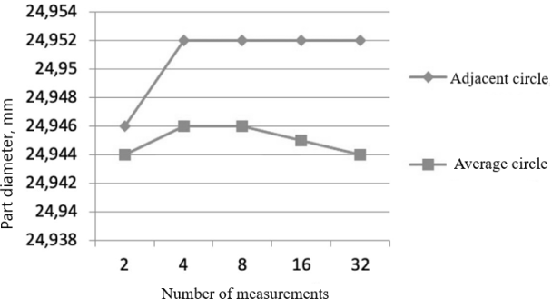

Section 3

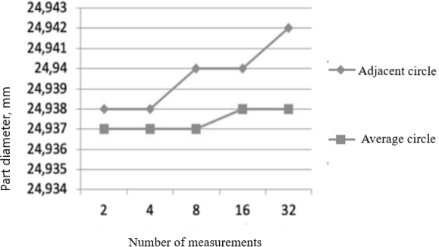

Fig. 1. Comparison of calculation results
The next experiment consisted in determining the diameter of the part not by individual sections, but by constructing inclined and straight cylinders.
To determine the diameter of the cylinder using the DEA Global CMM software and the Excel mathematical apparatus, the positions of the adjacent cylinder with and without tilt and, similarly, the average cylinder with and without tilt were found.
The position of the adjacent cylinder inclined at an angle described around the profile is defined as the solution of the minimization problem:

𝑅₀ → min, при 𝑅₀ − √(𝑥_{𝑖} − 𝑥₀)² + (𝑦_{𝑖} − 𝑦₀)² ≥ 0 (1)
𝑥₀ = 𝑧₀ + 𝑧 ∙ 𝑐𝑜𝑠𝜑 (2)
𝑦₀ = 𝑧₀ + 𝑧 ∙ 𝑐𝑜𝑠𝛾 (3)
where x0,y0,z0 are the coordinates of the cylinder center, xi and yi are the coordinates of the profile points, R0 is the radius of the adjacent cylinder, angle φ and angle γ are the angles of inclination of the adjacent cylinder to the X axis and to the Y axis, respectively.
The average cylinder is determined by the least squares method. In the presence of an array of profile points obtained from the measurement results, the coefficients of the equation of the average circle can be determined from solving the problem of minimizing the sum of squares:

𝑛 2
∑ [𝑅_{0ср} − √(𝑥_{𝑖} − 𝑥_{0ср})² + 𝑦_{𝑖} − 𝑦_{0ср}²]
𝑖=1

→ min

(4)

𝑥_{0ср} = 𝑧₀ + 𝑧 ∙ 𝑐𝑜𝑠𝜑 (5)
𝑦_{0ср} = 𝑧₀ + 𝑧 ∙ 𝑐𝑜𝑠𝛾 (6)

where x0ср, y0ср, z0 are the coordinates of the center, R0ср is the radius of the average cylinder, xi and yi are the coordinates of the profile points, n is the number of profile points.
The radii of the adjacent and average cylinders, without taking into account the inclination, were determined similarly, only the angles ϕ and γ were assumed to be 90 °, i.e. it was assumed that the profile of the original cylinder is perpendicular to the Z axis. The results of the diameter calculation are shown in Table 2.

Table 2. Results of calculated cylinder diameters

 | Diameter of the adjacent profile, mm | Diameter of the average profile,  mm
Diameter measurement by  individual sections | 24,958 | 24,938
Diameter measurement by  individual sections | 24,955 | 24,938
Diameter measurement with  a straight cylinder | 24,958 | 24,938

Table 2 shows that when determining the diameters along the adjacent profile, the angle of inclination of the cylinder affects the diameter value and the difference is 0.003 mm, and when calculating the average profile, the values do not differ. Therefore, when determining the diameter from the average circle, the angle of inclination of the cylinder will not significantly affect the results of measurements of the linear size.
The error in measuring the diameter of a part depends on many factors, one of the main ones is the method of determining the size. In this paper, a comparison of the determination of the size by the adjacent and by the average circles was carried out. The choice of the reference base depends on the constructive purpose of the part. Without this information, it is impossible to say exactly by which of the circles (adjacent or average) the actual values of the dimensions of the part should be determined. An experiment was carried out to determine the size of the part according to a two-point measurement scheme, the values of adjacent diameters are approximately equal when measuring 32, 16, 8 and 4 diameters, and at two there is a decrease in the result. Therefore, when measuring the diameter of a linear dimension, it is necessary to carry out at least 4 measurements. The construction of an inclined cylinder practically does not reduce the methodological error and at the same time requires large calculations.

References
- Григорьев С.Н., Телешевский В.И., Глубоков А.В., Педь С.Е., Глубокова С.В. Проблемы метрологического обеспечения подготовки производства в машиностроении // Измерительная техника. 2012. № 5. С. 27-29.
- Григорьев С.Н., Мастеренко Д.А., Телешевский В.И., Емельянов П.Н. Современное состояние и перспективы развития метрологического обеспечения машиностроительного производства//Измерительная техника. 2012. № 11. С.56-59.
- Григорьев С.Н., Конов С.Г. Развитие пространственной метрологии для обеспечения контроля сложных поверхностей в машиностроении//Контроль. Диагностика. 2012. № 12. С. 9-13.
- Емельянов П.Н., Педь С.Е., Холин И.Е. Разработка эталонной координатно- измерительной машины с ЧПУ // Информационно-измерительные и управляющие системы. 2012. Т. 10. № 8. С. 68-73.
- Glubokov A.V., Glubokova S.V., Shulepov A.V., Ped S.E. Spectral parameters of straightness deviation evaluation // Materials Science Forum. 2016. Vol. 876. P. 74-79.
- Педь С.Е. Исследование методической погрешности координатных измерений геометрических параметров деталей машин // Измерительная техника. 2014. № 3. С. 28-32.
- Педь С.Е., Дариенко Е.В. Оценка погрешностей координатных измерений параметров сечений цилиндрических поверхностей // Измерительная техника. 2011. № 8. С. 17-19.
- ГОСТ 25346-2013 (ISO 286-1:2010) Основные нормы взаимозаменяемости. Характеристики изделий геометрические. Система допусков на линейные размеры. Основные положения, допуски, отклонения и посадки. – М.: Стандартинформ, 2014. – 37 с.
Afonina Irina Viktorovna – graduate student of the Department of Measuring Information Systems and Technologies of MSUT «STANKIN»
Tel.: 8 916-737-98-83. E-mail: ira.afonina.94@mail.ru
Glubokov Alexandr Vladimirovich – candidate Sc. of Engineering, associate Professor of the sub-department "Measuring information systems and technologies" of MSUT "STANKIN".
Tel.: +7(499) 972-94-65. E-mail: al-glubokov@yandex.ru

УДК 65.011.56

Ponomarev K.S., Feofanov A.N., Grishina T.G.

An automated system of generating and providing verification data of measuring instruments as a tool for improving the efficiency of the organization's functioning

The article states that at the moment digitalization covers an increasing number of processes of the organization's functioning, including the processes of its metrological support. It is noted that information about the metrological maintenance of measuring instruments must be transmitted to third-party information environments. The methods of forming and providing information about metrological maintenance of measuring instruments to third-party environments using an automated system and without it are compared. The advantages of using an automated system are revealed, and it is also indicated that it can be implemented in the environment of the digital twin of an enterprise.
Keywords: automation, metrological service, digitalization, measuring instrument.

At the moment, the increasing degree of digitalization and automation of the activities of enterprises in all spheres of the economy dictates certain requirements for the processes of functioning of the organization [1]. Digitalization covers all processes of the company's functioning, including metrological support of its activities [2]. This applies both directly to the verification procedures of units, measuring instruments, and the processes of normative reflection of the results of metrological services, such as, for example, the registration of certificates of verification, the provision of information to third-party regulatory environments, the formation of protocols and other documents.
In addition, since September 24, 2020, according to Federal Law No. 102 "On Ensuring the Uniformity of Measurements", confirmation of the procedure for passing the verification device is verified by means of an entry in the Federal Information Fund for Ensuring the Uniformity of Measurements (hereinafter referred to as the FIF EUM). This Federal Information Fund was created in order to meet the needs of citizens, society and the state in obtaining objective and reliable information about the verification of measuring instruments. Thus, paper certificates of verification or notices of unsuitability lose their validity, and a digital record in the specified fund is a confirmation that the device has passed the verification procedure.
In this regard, the introduction of an automated management system for the activities of the metrological service is relevant, which provides the possibility of automated formation and provision of information about the metrological maintenance of measuring instruments (MI) to external information environments (for example, in the FIF EUM or its subsections).

As already noted, paper versions of verification certificates (and unsuitability notices) are currently optional for registration. However, at many enterprises accredited for the right to carry out MI verification, internal regulatory documents establish mandatory registration of paper versions of both verification certificates and unsuitability notices. In addition, these documents must be issued if the customer has submitted a corresponding requirement. At the same time, employees are obliged to provide information about the device to external environments after carrying out metrological maintenance of the device. Thus, there is an increased burden on verifiers, because the information in the paper version is almost completely identical to the information that is entered into external information environments. In this regard, the complexity of carrying out metrological maintenance of devices increases, the probability of error increases due to the repeated repetition of monotonous routine operations of documentation on the results of metrological maintenance of measuring instruments.
In order to assess the effect of the introduction of an automated system for generating and providing information on metrological maintenance of measuring instruments to the external environment in terms of reducing time costs, we will simulate the situation of providing one measuring instrument for passing the verification procedure to the metrology department of the enterprise. To do this, we will use a tool such as a Gantt chart.
A Gantt chart is a type of bar chart designed to visualize the sequence of stages of a process and their duration. The Gantt chart allows you to visualize the duration of each of the operations of the process, to identify the relationship between the operations and the duration of the entire process. The use of this chart allows you to clearly and effectively visualize the sequence of operations of a certain process and their duration.
Thus, for the process of generating and providing data on metrological maintenance of MI without the use of automation, we will build a Gantt chart, shown in Figure 1.

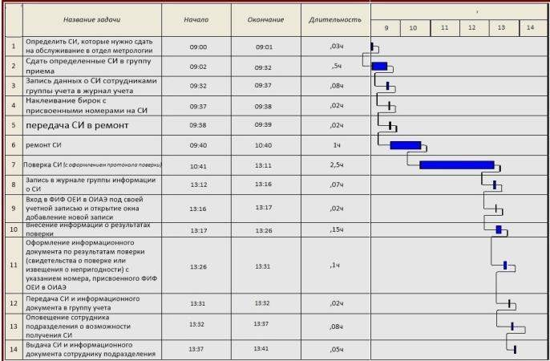

Fig. 1. Gantt chart of metrological maintenance of measuring instruments in the metrology department without the introduction of an automation system

In order to facilitate the analysis, we assume that one MI with the "repair" attribute has been submitted for metrological maintenance. The MI was received by the Department of Metrology, where it was sent for the repair procedure. The possibility of repair was confirmed, and after it was carried out, the MI was handed over for verification. According to the results of the inspection, it was revealed that the MI is suitable for use in the field of state assurance of the uniformity of measurements. Thus, the total time of metrological maintenance was 4 hours 41 minutes.
Now let's consider the Gantt chart for the process of forming and providing information about the metrological maintenance of MI using an automated system. Assume that the conditions of the simulated situation are the same as in the previous situation. For this case, the chart is shown in Figure 2.
For the case of using an automated system for generating and providing data on metrological maintenance of MI to the external environment, the process took 4 hours and 30 minutes, which reveals time savings for the conditions under consideration of more than 10 minutes per MI. This is a reserve for increasing the number of serviced measuring instruments for a certain time interval.
In order to more clearly visualize the sequence of interrelations between the stages of the process of forming and providing MI verification data using an automated system, we will present the metrological service process in the form of an IDEF0 notation.

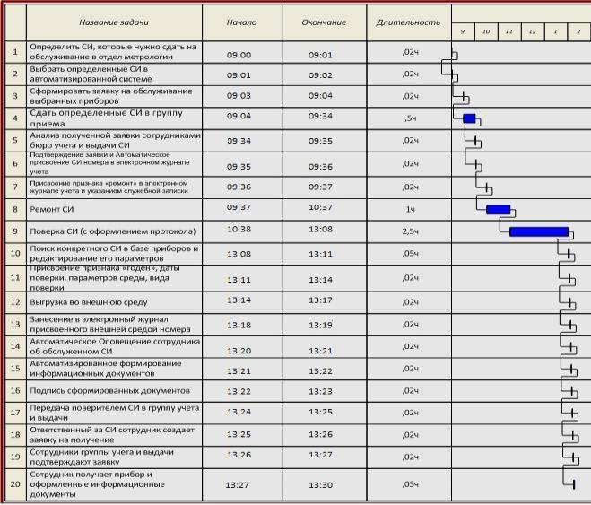
Fig. 2. Gantt chart of metrological maintenance of the device when using an automated system for generating and providing information about MI verification to an external information
environment

Carrying out the process of modeling metrological maintenance of the device by means of functional modeling of the IDEF0 notation serves as a means of identifying the stages of the process under consideration, their sequence and relationship, determining the mechanisms of this process and control actions.
The input data of the process of metrological maintenance of the MI, as shown in Figure 3, is directly the MI that has passed the operation of such maintenance, and for the second functional block, the result of the MI verification. At the first stage, the search for the serviced MI is carried out by an employee of the metrological department. The second stage of the process is the selection of this MI, after which the electronic journal of the verifier opens, where the latter assigns the verification status and other necessary information. Then there is an automatic formation of a file on the metrological maintenance of the MI based on the requirements of the external environment, after which the generated file is transmitted to the FIF EUM. The final stage of decomposition is the entry of the number assigned by the external environment into the verifier's log, after which an information document (a certificate of verification or a notice of unsuitability) is generated in an automated mode, which, along with a

record of the results of metrological maintenance, is the output.
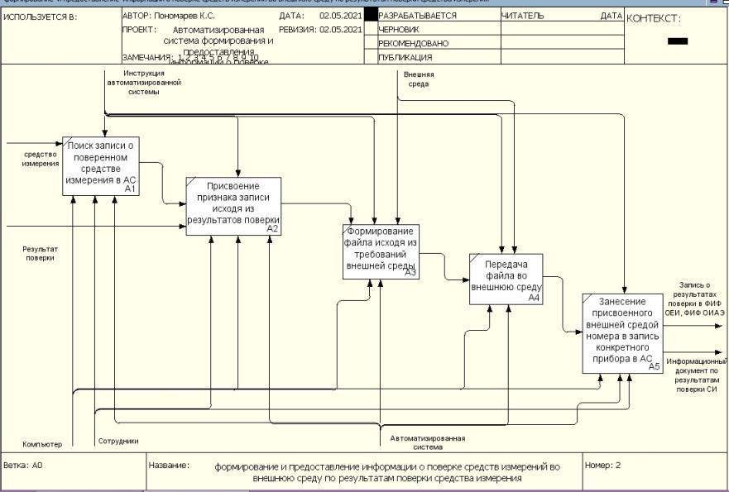
Fig. 3. Chart of the IDEF0 notation of the decomposition of the first level of the process of metrological maintenance of the measuring instrument when using an automated system for generating and providing information about MI verification to the external environment

As already noted, at the moment the development of digital technologies is an integral trend of scientific and technological progress in all spheres [3]. One of the digitalization products for enterprises is the so-called digital twin of production [4]. The digital twin allows you to simulate in virtual space the change in the condition and characteristics of the product, shop, the entire enterprise when the characteristics of any of its elements change due to the fact that the created virtual three-dimensional model of the product is connected to an information database in which each element can be assigned additional attributes [5]. When transmitting information from the automated activity system of the metrology department, the digital double will be able to track the status of a specific MI, the expiration date of the verification interval and other information. In turn, in the case of the implementation of the automated system in question into a single virtual space of a digital twin, employees of the metrology department can evaluate the metrological indicators of a particular MI in real time, analyze the statistics of measurements made with its help, track the main ranges of its operation in order to increase the reliability of the verification procedure [6]. In addition, an employee of the operating MI unit will have the

opportunity to evaluate the actual values of errors on specific ranges by accessing the MI verification protocol. Such access can be provided in order to eliminate uncertainty in the case when the MI used to ensure the measurement of any parameters indicates a value that exceeds the permissible limits for such a parameter. Analyzing the verification protocol, an employee of the operating unit will be able to assess whether the parameter value really goes beyond the normalized limits or the reason lies in the insufficient accuracy of the MI used.
Thus, the introduction of an automated system for generating and providing information about metrological maintenance of measuring instruments to the external environment will reduce the time spent on generating and providing the necessary data, reduce the influence of the human factor on the processes of issuing relevant documentation based on the results of metrological maintenance, and is also one of the tools to increase the level of digitalization of the enterprise as a whole.

References
- Feofanov A.N. The organization of a virtual enterprise - the future of production. Vestnik
MSUT «STANKIN», 2018, № 3 (46), pp. 101-105.
- Ponomarev K.S., Shutikov M.A., Feofanov A.N. Digital twin as an instrument of
enterprise digital transformation. Vestnik MSUT «STANKIN», 2019, № 4 (51), pp. 19-23.
- Kolchin A.F., Sumarokov S.V. Digitalization and life cycle management of engineering
products. Vestnik MSUT «STANKIN», 2019, № 2 (49), pp. 10-16.
- Ponomarev K.S. Digital twin as an implement for the development of enterprise information technologies. Prom-Engineering. Proceedings of the V Scientific and Technical Conference, Moscow-Chelyabinsk-Novocherkassk-Volgograd-Sochi, 2019, pp. 353 – 356.
- Ponomarev K.S., Feofanov A.N., Grishina T.G. Enterprise digital twin - instrument of digitalization the activity of the organization. Automation and Modelling in Design and Management, 2019, № 2 (4), pp. 11-17, DOI 10.30987/article_5cf2d1c56f8944.09486334.
- Ponomarev K.S., Feofanov A.N., Grishina T.G. Strategy of a digital twin of manufactory as a method of digital enterprise transformation. Herald of Modern Technologies, 2019, № 4 (16), pp. 23-30.

Ponomarev Kirill Sergeevich – postgraduate student of the sub-department of Automated Information Processing and Control Systems of MSUT “STANKIN”
sergej.ponomarev@bk.ru

Feofanov Aleksander Nikolaevich – PhD in Engineering, professor of sub-department of Engineering Graphics of MSUT “STANKIN”
feofanov.fan1@yandex.ru

Grishina Tatyana Gennadyevna — PhD in Engineering, professor of sub-department of Automated Information Processing and Control Systems of MSUT “STANKIN» grishena@mail.ru

УДК 378.02:621; 658.512.2 (075.8)
Karlov A.G.

Theoretical and methodological basis, functional capabilities of the Solving Mill 2.0 software product in the creation of innovative technologies and technical systems for industrial automation.

A brief history of the creation and development of the Solving Mill 2.0 software product is presented. The article provides information about the theoretical and methodological basis of the software. The functionality and resources of the software product are analyzed. Some information is given about the solved complex interdisciplinary problems in innovative design in the field of automation and robotics. The experience of individual and collective work with software for bachelors, masters, graduate students in the new TRIZ Laboratory of SevSU is described.

Keywords: interdisciplinary problems; theory of inventive problem solving; general theory of strong thinking; algorithm for correcting problem situations; template; functional model; process-hierarchical model; useful system modeling; modeling of a harmful system; accumulator of hypotheses; accumulator of ideas; resource manager; globally competitive innovative project.

Introduction
In recent years, in many publications, one can find convincing justifications for the fact that graduates of technical and technological specialties should be able to conduct innovative development and experimental research of problems associated with the creation of competitive domestic products, ensure the replenishment and improvement of the knowledge base of the national technological environment, its security. The trend of increasing the importance of such knowledge, skills and abilities that form the inventive thinking of engineering personnel is becoming more and more obvious [1-5].
As never before, the tasks of increasing the effectiveness of human-machine systems that provide an effective search for conceptual inventive solutions in the process of working on innovative projects for the automation of hardware and systems are becoming relevant. This

corresponds to the postgraduate training program in such scientific specialties as 05.13.06 "Automation and control of technological processes and production (by industry)" and those close to them. These programs recommend the introduction of disciplines aimed at obtaining by students competencies that provide non-trivial inventive thinking. These programs should be based on world experience in applying the theoretical foundations, methods and algorithms for the intellectualization of solutions to applied problems not only in the field of automation and process control, robotics, but also in many interdisciplinary studies.
The creation of radically new, breakthrough technologies and systems for automating technological processes, sharp shifts in the development of devices and methods at the level of patents in such areas as robotics, new materials, additive technologies require a radical restructuring of the thinking of inventors. The skills and abilities of a new technology of thinking, in contrast to the traditional trial and error method, are becoming more and more relevant.
As is known, G. S. Altshuller made a breakthrough in inventive work in the late 1940s and early 1950s. He analyzed a huge database of patents in order to understand the principles that guided the inventors when obtaining new ideas, and to highlight the meaning of the actions of the inventor when moving from one version of a technical device to another. As a result, it became clear that inventors use common transformation methods to improve completely different devices.
The analysis of patent databases gave another important result: it helped to identify development directions that are common for various classes of technology. On this basis, the laws of development of technical systems and other important components of TRIZ (Theory of Inventive Problem Solving) were formulated [6, 7].
Few young people who have received and are receiving higher and secondary specialized technical and technological education know that in the 80s in the Soviet Union in many cities the country's first schools of inventive creativity, public universities of scientific and technical creativity were organized. The total number of such schools exceeded 500. In 1970, the School of a Young Inventor was established in Baku (USSR, Azerbaijan), which in 1971 grew into AzPIIC(Azerbaijan Public Institute of Inventive Creativity) - the world's first TRIZ training center.
Our country owed the formation of this unique system of teaching inventive creativity to Genrikh Saulovich Altshuller (pseudonym - Genrikh Altov) - the author of the theory of inventive problem solving - the theory of development of technical systems, the author of the theory of the development of creative personality, inventor, writer. Having studied tens of thousands of patents and inventor's certificates, combining the methods and approaches that

existed before him into a single system, he discovered the basic principles of inventive creativity and showed that the process of creating inventions is largely manageable [6, 7].
When TRIZ first appeared, it seemed that it was enough to introduce engineers to its tools so that they began to actively apply new techniques at existing workplaces, research institutes and design bureaus. The first textbooks were produced, TRIZ was promoted at seminars for IT and in circles of technical creativity of the youth. Software products were developed that automate routine elements of the inventor's work. However, not every specialist who has read a book about TRIZ or attended a specialized seminar was ready to use TRIZ in practice. And yet, engineers who managed to enter the TRIZ community not in words, but in deeds, persistently developed and popularized inventive search tools. Thanks to their efforts, a special professional role began to form – the solver of inventive tasks [8, 9].
With one of the well-known experts in the TRIZ community, TRIZ Master Nikolai Andreevich Shpakovsky, the author of this article had the honor to collaborate creatively for several years and prepare for publication a number of interesting publications [5, 10, 11, 12] in the field of application of the original software product Solving Mill 2.0. This product has shown high efficiency in the creation of innovative technologies and technical systems for industrial automation.
In 2016 and 2019, the author of this article and Shpakovsky N.A. were invited by the organizers of the All-Russian Engineering Competitions (REC) to St. Petersburg Polytechnic University and the Crimean Federal University to prepare and conduct the so-called "TRIZ Trajectory" as part of this already well-known in Russia review of the finalists of the REC-2016 and REC-2019. Within the framework of these forums, another approbation of the Solving Mill
  - software product, which was created by a creative team led by Shpakovsky N.A., took place. REC participants, after a brief introduction to the Solving Mill 2.0 User Guide, were dynamically and successfully looking for conceptual solutions to real-world production problems that were provided by REC's industrial partners. The author of this article had far-reaching plans for joint creative activity with Nikolai Andreyevich Shpakovsky, however, in November 2021, he died prematurely in the prime of his creative powers due to the COVID.

    - A brief history of the creation and development of the Solving Mill 2.0 software product. The inventive solutions search tools developed by G.S. Altshuller, such as the ARIZ-85 algorithm and others, were good both for solving the problem and for teaching. However, attaching these two different functions to the algorithm led to its re-complication. Although it was quite acceptable for manual work, it was not suitable for creating software, where dry
algorithmicity is very important, and it is difficult to program the work of thought.

Thus, the developers of the TRIZ software faced two tasks.
- The first and foremost is the creation, thinking through an effective, logical and simple process for solving a problem that would lend itself well to programming.
- The second is programming itself, building a computer structure of the TRIZ algorithm and a set of heuristic tools, providing a dialogue with the user, developing a friendly interface.
Intellectual systems were built on the basis of the objective laws of development of technical systems revealed in TRIZ [9]. It is following the laws of development that makes it possible to make manufactured products and developed technologies competitive. This avoids many costly design mistakes and improves the quality of ideas that define the main indicators of new technology. The use of TRIZ software helps an engineer, designer, technologist in solving complex inventive problems, including when conducting a functional cost analysis.
Further development of TRIZ software went hand in hand with the improvement of computer technologies. Thus, the possibility of obtaining information necessary for solving inventive problems has significantly developed. This greatly enhanced the decisive capabilities of the software, because you can find a lot of analogues that can be used to solve the problem. This feature is certainly useful, supported by the development of the logical part of the software. It is interesting that here the law of uneven development of parts of the system is fully manifested - the development of programs for searching for information is not always accompanied by an increase in the logical part.
Now there is a trend of positioning inventive software. So, for example, the products of the Invention Machine project and the Ideation company are complex, expensive programs that only a large company or university can afford to purchase. For an ordinary user, these software are not affordable, and their functionality is excessive. In addition, these software exist only in English and are therefore of little use to a Russian-speaking user.
In addition to solving software, there are special software for learning TRIZ. Most often, the approach of developers is that they consider TRIZ educational software as a means of program-oriented learning. That is, the trainee is given information on sections, mainly on TRIZ tools, after reading which, the person must answer questions on the text. At the end of the training, the “passed” information should be combined into an algorithm for solving the problem. Even under the most favorable circumstances, the trainee receives only knowledge of TRIZ, the training component is minimal, which is completely insufficient to develop the skill of solving an inventive problem.
Specialists are well aware of the "Inventing Machine" (IM) family of systems. It is a software product designed to support the solution of complex engineering and inventive tasks.

Support can be carried out at the earliest stages of engineering design, when the principles of operation and architecture of the future machine, device are selected. Software can also be used to solve problems arising from the improvement of existing devices, machines, and technological processes. The theoretical basis and knowledge base of the IM system is TRIZ.
The main advantage and feature of the system under consideration is the independence of the principles embedded in the system from the field of technology.
The laws of the development of technical systems, the principles of conflict resolution and methods of controlling the designer's thinking work equally effectively everywhere, so the "Inventing Machine" family has been used in any field of technology related to the processing of substances and fields, for example, in mechanical engineering, electrical engineering, microelectronics, etc. [13].
This is confirmed by the experience of operating the system at enterprises of various industries: mechanical engineering, metallurgy, electronics, chemical engineering, aircraft construction, medical equipment, construction, etc.
In general, the system occupies the highest level in the CAD hierarchy. The development of conventional CAD is moving towards elementary intellectualization, which leads to the appearance of some properties inherent in expert systems (automatic generation of dialogue, explanation of logical inference, etc.). The "inventing machine" is developing along the path of more complete assimilation of the theory of development of technical systems, as well as towards conventional CAD. In general, the system can be attributed to the class of creative thinking support systems. The knowledge base of the system consists of methods of the theory of inventive problem solving (TRIZ), the main mechanisms of which can be automated using artificial intelligence.
Such software worked well with clearly formulated tasks, but it turned out that its analytical part was weak. Therefore, the following versions called TechOptimizer already contained elements of functional and process analysis, but the dialogue with the user was minimized. The center of gravity was shifted to the use of technical information and heuristic tools.
Further development of the idea was the creation of a new version of the software – Gold Fire [5]. The solution-making part of the software has not undergone significant changes, the development of the software has gone towards forcing the analytical part and developing new modules. Semantic information search modules and a model of working with the user on joint problem solving were added.
The main problem of existing software stems from the unconscious belief that a computer can invent itself, without human involvement. This maxim leads to the fact that such a structure

is being developed for software that can work independently to the maximum. There is an implicit verbalized hope that a computer can invent itself, so attempts are involuntarily made to shift all the functions of a human solver to the program. At the same time, it is necessary to take into account the participation of a person in working with software. Such a contradiction inevitably leaves an imprint on the structure of software, since it is quite difficult to combine these two types of software without losing meanings [5].
What kind of software should there be that a modern inventive problem solver needs? Probably, we can say this: software should not compete with a person, a problem solver. On the contrary, he should adapt to it as much as possible and help a person to fully reveal his creative abilities. That is, it should be a soft interlocutor, a soft assistant, leading the solver in the process of solving the problem.

    - The software product Solving Mill 2.0., the theoretical and methodological basis of the software.
Based on the requirements for effective inventive software, the goal of the Solving Mill project is to offer to the market a computer program directly designed to solve an inventive task from describing a problem situation to obtaining and evaluating a solution idea. To give the user an assistant, a competent and logical interlocutor who guides him in solving the problem according to an effective algorithm, asks the right questions and reminds him what needs to be done and what related information to apply.
The idea of creating such a program is not new; such an approach – to work directly through the algorithm of solving the problem - lay at the origins of the well–known program "Inventing Machine" (versions 1.0 – 1.5). However, then the concept of software was radically changed [5,8,13].
A computer program should be inexpensive, accessible to a wide range of users and at the same time sufficiently effective. Here it is necessary to avoid two extremes - not to simplify the software to primitiveness and not to overcomplicate it. To meet the requirements of simplicity, the algorithm must contain the minimum number of key, reference points that must be passed when solving the problem. The requirement of complexity is satisfied by the fact that the transition between the points of the algorithm can be carried out in a variety of ways - from a simple guess to the use of the most complex and effective TRIZ tools. That is, the algorithm should lead the solver step by step from point to point, showing what result he should get after each step.
Methods for performing steps are specified in each specific case. Such an algorithm is a fractal cluster, a tree structure (Fig. 1).

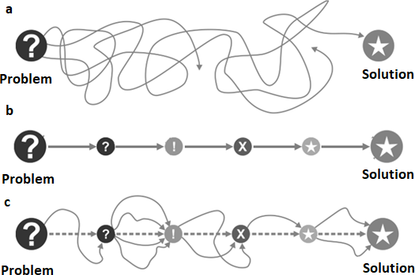

Fig. 1. Different approaches to solving the problem (the way from problem to solution): a) unorganized process;b) rigidly deterministic algorithm; c) fractal algorithm [5]

Transitions between points imply the presence of mini-algorithms for applying TRIZ tools and rules for performing additional steps. Mini-algorithms can be refined and developed indefinitely, trying to cover all the main types of problems being solved, but the main steps of the algorithm do not change.
Such an understanding of the process of solving an inventive problem was put into the methodological basis of the algorithm for correcting problem situations in ACPS [5, 8, 9].
The algorithm was tested at SAMSUNG and POSCO (South Korea) during many years of work with practical inventive problems in the field of microelectronics, semiconductors, metallurgy, medicine, displays of various types, production of home appliances, etc. It showed high efficiency, and on its basis the Solving Mill computer program was developed. This is an effective software product for troubleshooting, simple and easy to learn and use. The theoretical basis of the software is TRIZ. The software is organized in such a way as to direct the user to a strong solution in the fastest and most efficient way.

    - What tasks does Solving Mill solve?
The Solving Mill software is designed to support the solution of non-trivial technical problems from analyzing the problem situation to checking the effectiveness of the solution obtained. These tasks may be related to the processes of development, production, storage,

transportation, sale of products, organization of the enterprise, advertising, etc. The algorithm and tools are universal for problems from any industry, and can be applied to other areas of activity where non-trivial problems arise.
The product obtained when using the Solving Mill is a conceptual solution aimed at eliminating problematic situations that arise during the development, manufacture, operation and disposal of a device or technology. Therefore, Solving Mill is of interest to such users as engineers, designers, researchers, technologists, project managers, specialists in innovation departments, patent experts, company executives, etc. That is, for all those who, by the nature of their activities, are faced with the need to solve non-trivial problems.
A separate area of application of Solving Mill is for organizing the training of university students. The software becomes the core around which it is easy to organize both the educational process and practical classes, and this can be done both in contact with the teacher and remotely.
The structure of the program provides for a thorough analysis of the problem situation with the construction of cause-and-effect interactions and access to optimal tools for solving the problem. Based on the analysis, the program provides the construction of contradictions and other problem models, problem solving with the help of mini-algorithms and tools developed in TRIZ and related disciplines. The user can reinforce the received solutions with the help of development lines. Since the Solving Mill program is designed for one very specific purpose - to correct problematic situations, it was possible to make it effective, simple and easy to learn and work with. [5, 8, 14].
Solving Mill's main solving tool is a step-by-step template for working with a problem that is filled in as the user moves towards a solution.
The template is organized according to the algorithm adapted for software use. The user fills in a kind of “solution card”: answers questions, fills in the required cells, places descriptions, illustrations, diagrams, conclusions and other content that is generated in the course of working with the task into the template. Following the template, the user goes through all the stages of working with the task step by step. The user can easily navigate through the solution map, having the opportunity to examine and work out one or another part of it in more detail, go back and correct the solution. Thanks to this, when working, the user sees and evaluates the entire project situation: how far he has advanced in the solution, whether there are any intermediate results, etc.
The template contains 11 steps arranged horizontally in sequence. Each step has its own separate field. It gives instructions to the user on what to do. For example, you need to describe something, enter data into schemes, perform actions in an operator, draw a conclusion, etc. The

completed template provides complete and visual information about all the steps of working with the task.
At the entrance to the template, the user has a description of the problem situation in free form, upon completion of the work, he receives a number of ideas on how to solve the problem and improve the problem situation, suggestions for implementing the ideas received, a fixed process of working on the problem in the form of well-structured texts, drawings, schemes (that is, a ready-made report on the project) and a draft of the claims, which is automatically generated based on the recorded data. If necessary, the user can get help, instructions, hints and examples of solved problems. To do this, the main solution tool - the template - has five levels of information support (Fig. 2).
In case of difficulties in solving the problem and using the template, you can use short hints that are located at each cell. The hint shows what information the program needs from the user and how to correctly present the required data.
There are operators for performing complex actions and for working with TRIZ methods. Each operator opens in a separate window and has its own special interface. With the help of operators, auxiliary actions are performed: building models, processing the information received, generating ideas, etc. The result of work in each of the operators is placed in the template, and all the accumulated auxiliary information is stored inside the operator, the user has access to it at any time.
In addition to the ACPS algorithm, the software uses mini-algorithms known in TRIZ and developed by the authors of the software.

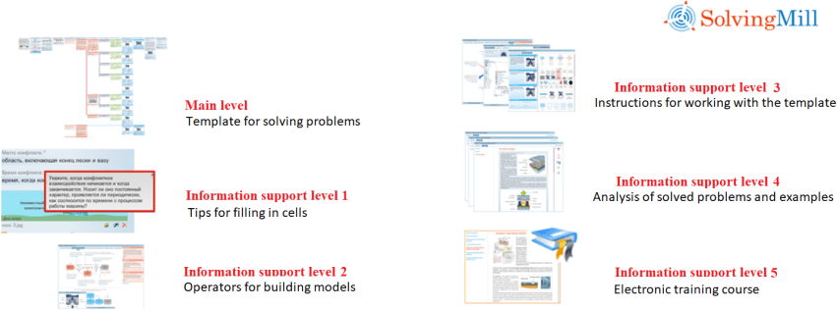
Fig. 2. Information support levels of Solving Mill software [5, 14]
These algorithms are aimed at supporting the solution process: building a model of a technical system; identification of causal relationships; building conflict interaction in the system; construction and analysis of a hierarchical process model; building a model of a harmful

system; putting forward hypotheses to eliminate the conflict; construction of such problem models as “su-field”, technical and physical contradiction and others; building requirements for the resource "unknown resource - attribute - attribute description"; the use of the evolution tree and development lines to intensify the idea of a solution, and many others.
In addition, the user has instructions at his disposal that describe in detail how to perform each step of the algorithm and use methodological tools. For a more complete understanding of the features of using the Solving Mill software and self-study of the problem solving process, the user is offered a training course.

    - Examples for learning as part of the Solving Mill software - end-to-end case studies on solved problems.
Each example is made in accordance with the matrix basis of the software: strictly according to the steps of the template (Fig. 3). This makes it possible to better understand both the process of solving the problem and the features of working with the template and operators.
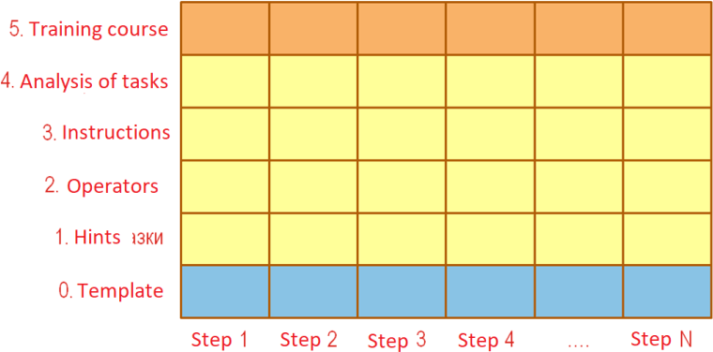

Fig. 3. Matrix scheme of Solving Mill software [5, 14]

4.1. Example of a case study (report) on a solved problem on the topic: "Processing of metallic parts with inclusions".
Generator: Solving Mill version sm-2.0.

Describe the problem situation in a free form
The workpieces obtained by casting into the ground are machined. The problem is that there are abrasive inclusions in the workpiece. When the cutting tool hits the switch on, it breaks.
It is necessary to eliminate the breakdown of such a cutting tool as a milling cutter.

The method of making workpieces is casting into a mold. And that's assuming you can't change it.

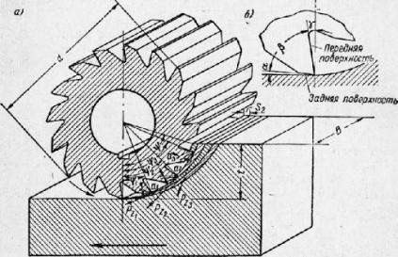

Can you formulate the condition of the problem?
 Yes No

Make up the condition of the problem according to the following scheme
The system for processing metal on surfaces consists of a machine, a cutter, a clamp and a workpiece. In the normal course of business, the system works as follows: the part is fixed in the clamp, the cutter rotates and cuts off the metal layer with its teeth.
In this case, the problem arises that the teeth of the cutter run into hard inclusions and break. You need to fix broken teeth.
Restriction: you cannot change the method of manufacturing the workpiece.

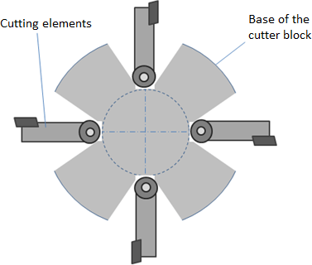

Determine available resources

Spatial resources (operational zone)
The space that includes the cutter and the cutting zone of the workpiece.

Temporary resources (operational time)
Milling time.

Material resources
Machine, cutter, clamp and workpiece.

Field resources
Electric current, energy of rotation of the cutter.

Propose a solution to the problem in the best known or easiest way
Perform the teeth of the cutter in the form of cutters and install them on hinges. Then, upon contact with a solid inclusion, the tooth will deviate and will not break.

Is this solution acceptable?
Yes.
- No.

Why are you not satisfied with the solution? There is no minimally acceptable solution at all. There are problems with the required action.
When implementing the solution, another parameter of the system deteriorates.
- There is a contradiction to the system component.

Formulation of the "Physical contradiction" problem model
The cutter must be rigid in order to cut metal well.
The cutter must be hinged in order to deviate when it hits a solid inclusion.

Which attribute of the component does the requirement relate to?
Size, shape, position.
Surface.
The internal structure of the material.
- Dynamism Manageability

Select the type of contradiction:

- Contradictory parameter values are required in the same place. Conflicting parameter values are required at the same time.
Conflicting parameter values are required in the same place at the same time.

Select the appropriate conversion:
Change the degree of dynamism of the component depending on the working conditions
 Change the dynamism of component parts depending on the working conditions

Solution model
To resolve the contradiction associated with the dynamism attribute, spread the conflicting parameter values over time: change the dynamism of the component parts depending on the working conditions.

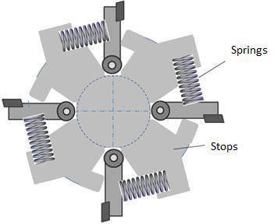

Specify how this transformation can be applied to solve this problem:
Mount the cutter to the cutter pivotally, but install the X-component, which would not allow the cutter to deviate under normal operating conditions, but allow it to deviate back when it hits a hard inclusion.

Do I need to convert the system?
 Yes No

What system attributes and how should be converted? Layout

Structure (links) Controllability Other
It is necessary to insert the X-component into the attachment of the cutter. Such an X-component can be a spring that does not allow the cutting element to deviate back under normal load, and when encountering a solid inclusion, it allows a deviation back.

Is it necessary to further convert system components?
Yes
 No

Preliminary solution
To improve the Complexity parameter, switch from a symmetrical form of the component to an asymmetric one. That is, to make the groove for the cutting element not symmetrical, but deflected back along the rotation of the cutter. To do this: Attach the cutter pivotally, but install the X-component, which would not allow the cutter to deviate under normal operating conditions, but allow it to deviate back when it hits a hard inclusion. Shape: Cutter groove shape

Other: You need to enter the X-component into the cutter holder. Such an X-component can be a spring, which does not allow the cutting element to deviate back under normal load, and when it encounters a hard inclusion, allows it to deviate back.

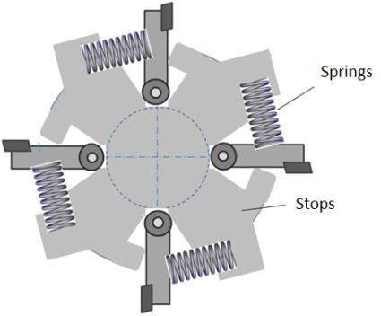

Are you satisfied with this solution?
Yes

- No

Why are you not satisfied with the solution? There is no minimally acceptable solution at all. There are problems with the required action.
- When implementing the solution, another parameter of the system deteriorates. There is a contradiction to the system component

Formulation of the problem model "Technical contradiction"
The parameter "Impact load on the cutting element"
is improving, the parameter "Complexity of the milling cutter" is unacceptably deteriorating

Choosing a solution tool
- G. S. Altshuller's technique selection matrix. Operator TI-transformer.

Selection of techniques through the G. S. Altshuller matrix Improved parameter
Impact load on the cutting element

Typical parameter 1
Force.
What gets worse at the same time? The complexity of the milling cutter Typical parameter 2
The complexity of the device.

10. Preliminary action
- Perform the required action in advance (in full or at least partially)
- Arrange the objects in advance so that they can take effect without spending time on delivery and from the most convenient place.
18. The use of mechanical vibrations
- To bring the object into oscillatory motion.
- If such a movement is already taking place, increase its frequency (up to the ultrasonic frequency).
- Use a resonant frequency.

- Use piezovibrators instead of mechanical vibrators.
- Use ultrasonic vibrations in combination with electromagnetic fields.

26. Copying
- Instead of an inaccessible, complex, expensive, inconvenient or fragile object, use simplified and cheap copies of it.
- Replace an object or a system of objects with their optical copies (images). Use a zoom change (increase or decrease the copies).
- If visible optical copies are used, switch to infrared or ultraviolet copies.
35. Change of physical and chemical parameters of the object
- Change the aggregate state of the object.
- Change the concentration or consistency.
- Change the degree of flexibility.
- Change the temperature.

Are the ideas obtained using the hints of the G. S. Altshuller matrix useful?
Yes.
  - No

Choosing a solution tool
G. S. Altshuller's technique selection matrix.
  - Operator TI-transformer.

Which parameter has deteriorated?
Complexity

Which operational parameter of the system is affected by the deterioration of the specified parameter?
Performance. Reliability.
Product quality.
Adaptability.
Economy.
Manageability.
 Simplicity.

To improve the specified parameter, use the transformation:
- Convert a system component.
Introduce a new component into the system. Transform an action in the system.
Transform the system.
Special conversion.

Specify the conversion method:
Divide the component into parts or increase the degree of fragmentation. Separate the interfering part from the component.
Provide the desired property in the component part. Use the "vice versa" principle.
Change the physico-chemical parameters of the component.
Ensure that the component performs several functions simultaneously.
Ensure that the component or its parts that have fulfilled their purpose are discarded. Change the optical properties of the component.
 Go from the symmetrical shape of the component to the asymmetric one. Combine components that are homogeneous or intended for related operations. Change the shape of the component to spherical.
Use a copy of the component.
Replace an expensive durable component with a cheap one, sacrificing durability

Solution Model
To improve the Complexity parameter, switch from a symmetrical form of the component to an asymmetric one.
That is, make the groove for the cutting element not symmetrical, but deflected back along the rotation of the cutter.

Which component of the system can be converted in this way?
The machine.
 Milling cutter.
The clamp and the workpiece. None of them fit.

What are the attributes of the "milling cutter" component and how should it be converted?

Size Shape
 Shape of the groove for the cutting element Surface
Internal space Material Dynamism Manageability Other

Do I need to convert the system?
Yes.
- No.

Do I need to convert the system components additionally?
Yes.
- No.

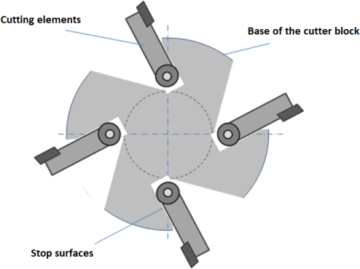

Preliminary solution
Go from the symmetrical shape of the component to the asymmetric one. That is, to make the groove for the cutting element not symmetrical, but deflected back along the rotation of the cutter.

Are you satisfied with this solution?
 Yes.
No.

Formulate the final solution
Change a symmetrical component shape to an asymmetric one. That is, to make the groove for the cutting element not symmetrical, but deflected back along the rotation of the cutter. This will make it possible to deflect the cutting element back in advance. When the cutter rotates, centrifugal force will act on it and return the element back to the radial position.
This will be similar to the action of a spring, but without the use of a spring.

Project Completion

Congratulations! The project report presents all the solutions found in the form of an automatically generated workpiece patent formula.
Item 1. A device that includes a machine tool, a milling cutter, a clamp and a workpiece in which to switch from a symmetrical component shape to an asymmetric one. That is, to make the groove for the cutting element not symmetrical, but deflected back along the rotation of the cutter. This will make it possible to deflect the cutting element back in advance. When the milling cutter rotates, the centrifugal force will act on it, and return the element back to the radial position.
Item 2. The device according to point 1, in which to make the teeth of the cutter in the form of incisors and install them on hinges. Then, upon contact with a solid inclusion, the tooth will deviate and will not break.
Item 3. The device according to item 1, in which to insert a spring into the fastenings of the cutting element to the base of the cutter. The spring does not allow the cutting element to deviate back under normal load, and when encountering a solid inclusion, it allows a deviation back. The forward deviation of the cutting element can be limited by stops.
Item 4. The device according to item 1, in which to deflect the cutting element back in advance. When the milling cutter rotates, the centrifugal force will act on it, and return the element back to the radial position. This will be similar to the action of a spring, but without the use of a spring. Item 5. The device according to item 1, in which to move from the symmetrical form of the component to the asymmetric one. That is, to make the groove for the cutting element not symmetrical, but deflected back along the rotation of the cutter.

Conclusion
The training of a modern engineer who is able to independently generate conceptual solutions for current projects in the fields of automation of technologies and technical systems, robotics, mechatronics to ensure globally competitive products should include a knowledge base of algorithms and software products that support the processes of correct formulation and effective implementation of innovative design processes. This corresponds to the postgraduate training program in such scientific specialties as 05.13.06 "Automation and control of technological processes and production (by industry)" and those close to them.
The long-term experience of creative cooperation of the Department of Instrument Systems and Automation of Technological Processes of the Polytechnic Institute of Sevastopol State University and the team of Target Invention (Minsk, Belarus) in the field of systematic tools of the General Theory of Strong Thinking and the Theory of Inventive Problem Solving allowed to organize a specialized laboratory TRIZ in 2021. There are 20 workplaces in the Laboratory, which are equipped with access to the Solving Mill 2.0 software product. This makes it possible to provide the necessary support to students and postgraduates during training and contributes to the formation of skills and abilities to effectively search for breakthrough solutions to complex problems with the possibility of reaching the level of inventions and know-how.

References
- Соболев А.Н., Некрасов А.Я.,. Арбузов М.О. Совершенствование методов подготовки специалистов в области машиностроения// Вестник МГТУ «Станкин». 2017. № 2 (41). С. 107-111.
- Боровков А.И., Рябов Ю.А., Марусева В.М. Новая парадигма цифрового проектирования и моделирования глобально конкурентоспособной продукции нового поколения. Цифровое производство, методы, экосистемы, технологии. Рабочий доклад департамента корпоративного обучения Московской школы управления Сколково. 2018, с. 24-43.
- Инженерное образование: мировой опыт подготовки интеллектуальной элиты// Рудской А.И., Боровков А.И., Романов П.И.,. Киселева К.Н. – СПб.: Изд-во Политехн. ун-та, 2017.
– 216 с.
- А.Г. Карлов, О.В. Филипович. Ресурсы, альтернативы и противоречия образовательных программ подготовки инженеров цифровой экономики

с компетенциями нетривиального изобретательского мышления// Вестник МГТУ
«Станкин» № 1 (56), 2021, с. 23-32
- Карлов А.Г., Шпаковский Н.А. Идеи, изобретения, инновации в сфере автоматизации технологий и технических систем: учебное пособие. — М.: Центр каталог, 2019. — 536 с. (Вузовский учебник). ISBN 978-5-903268-25-2.
- Официальный сайт Г.С. Альтшуллера, создателя ТРИЗ-РТВ-ТРТЛ. URL: http://www.altshuller.ru/
- Альтшуллер Г.С. Найти идею. Введение в ТРИЗ - теорию решения изобретательских
задач. Издательства: Альпина Бизнес Букс, Альпина Паблишерз, 2008 г. 410 с.
- Шпаковский Н.А.. ОТСМ-ТРИЗ. Подходы и практика применения. Издательство: Инфра-М., Москва, - 2018 г. 348 с.
- Шпаковский Н.А., Новицкая Е.Л. ТРИЗ. Практика целевого изобретательства. Учебник.
- М.: Форум, 2011. - 336 с. - (Высшее образование).
- Карлов А.Г., Шпаковский Н.А. Особенности алгоритмов решения изобретательских задач и софта для поддержки процессов проектирования средств автоматизации инструментами ОТСМ-ТРИЗ-технологий. Автоматизация и измерения в машино- приборостроении. Научный журнал. Выпуск №4 2018 г., с. 3-17.
- Карлов А.Г., Шпаковский Н.А. Повышение надёжности работы оборудования для нанесения токопроводящего слоя на поверхность микросхемы на основе применения программного продукта Solving Mill 2.0. Автоматизация и измерения в машино- приборостроении. Научный журнал. Выпуск №2, (14), 2021, с. 3-14.
- Карлов А.Г., Шпаковский Н.А. Процедуры и результат применения софта Solving Mill 2.0 при модернизации установки для производства пластиковых гранул. Автоматизация и измерения в машино-приборостроении. Научный журнал. Выпуск №1, (13), 2021, с. 3-12.
- Хоменко Н.Н., Кучерявый Д.П. "ИЗОБРЕТАЮЩАЯ МАШИНА" – семейство систем поддержки решения изобретательских задач. URL: https://otsm- triz.org/sites/default/files/ready/im_khomenko_kucheryaviy.pdf.
- Софт Solving Mill. URL: http://www.solving-mill.com/

Karlov Anton Georgievich - candidate Sc. of Engineering (PhD), associate professor of the sub- department of “Instrument systems and automation of technological processes” of Polytechnic institute of The Sevastopol state university.
E-mail: antkar38cam@gmail.com

УДК 621.91.01
Fomin E.V., Snegireva K.K.

Planning an experimental study of cutting of alpha titanium alloys

The article presents the sequence of setting up an experiment to study the machinability of cutting alpha titanium alloys from the point of view of obtaining the required quality of the processed surface. The study is based on the hypothesis of the existence of a relationship between parameters that assess the state of the machined surface - roughness, microhardness and residual stresses, with a minimum value of dissipation of the energy supplied to the workpiece. As a criterion for assessing the degree of dissipative processes arising in the material during cutting, it is proposed to use the coefficient of efficiency of energy dissipation, which is widely used in the theory and practice of metal working by pressure to determine the modes of stable plastic deformation.
Keywords: alpha titanium alloys, metalworking, experiment planning, machinability by cutting.

Alpha titanium alloys, due to their high strength at low temperatures, good weldability, ductility during bending and thermal stability, make it possible to obtain high-quality welded joints in a large range of sizes [1]. High corrosion resistance and low specific gravity have made these alloys one of the most common in underwater shipbuilding. They are widely used as a material for the manufacture of hull structures, fasteners, fittings of pipelines of underwater objects.
The disadvantages of titanium alloys include their low machinability by cutting with blade and abrasive tools. High heat generation during chip formation and low thermal conductivity of the processed material lead to intensive wear of the cutting tool, and a low modulus of elasticity contributes to the occurrence of vibrations. These physical properties of titanium alloys cause defects, which manifest themselves in an unstable value of surface roughness along the length of the product during finishing and in the appearance of white spots during subsequent oxidation. At the same time, the limitation of the use of grinding titanium alloys makes this problem even more acute.
The purpose of this study is to determine the rational modes of finishing turning of alpha titanium alloys, allowing achieving the required surface quality, estimated by the parameters of roughness, microhardness and residual stresses of the surface layer.
The hypothesis on which this study is based is that the zone of plastic deformation is limited by some curved surface around the cutting edge of the tool. The boundaries of this

surface can be removed in various ways from the geometric location of the contact points of the tool and the workpiece, depending on the cutting conditions and process parameters. If you set a cutting mode in which the material will not have time to completely dissipate energy due to structural transformations or heat, then macroscopic instability of plastic deformation occurs [2], which is expressed by localization in a narrow zone.
In this case, it can be assumed that during cutting this will lead to a decrease in the zone of plastic deformation and create the maximum possible prestressed state in the layers of the workpiece located along the path of the tool. In addition, it is important that dissipative processes of material recovery such as dynamic recovery and recrystallization do not occur in the material under the prevailing temperature and velocity conditions, which significantly reduce the level of stresses in the material, giving it greater plasticity.
The amount of energy that is spent on dissipative processes can be determined using a parameter called the "coefficient of efficiency of energy dissipation" η. It allows us to estimate the total effect of all dissipative processes during deformation of the material [3]. The lower the value of the specified coefficient, the less efficient the energy dissipation in the material and the greater the probability of localization of deformation, that is, the loss of stability of the material.
Thus, the regulation of the value of energy dissipation, and, as a consequence, the size of the propagation of the primary plastic deformation zone, will allow you to control the quality parameters of the treated surface.
The methodology for determining the modes that allow guaranteeing the required combination of quality indicators of the treated surface is based on determining the values of the efficiency coefficient of energy dissipation η and comparing them with the values of the quality parameters of the treated surface under the same technological modes by means of mathematical statistics methods.
The efficiency coefficient of energy dissipation η is determined by the formula [4]
𝜂 = 2𝑚 ,
𝑚+1
where m is the velocity sensitivity index, which is a function of the tangential stress τ and the strain rate έ, which, in turn, can be represented as dependencies [4]
𝜏 = 𝑓₁(𝑃_{𝑧}, 𝑘_{𝑙}, 𝛾 , 𝑆, 𝑡),
𝜀́ = 𝑓₂(𝑘_{𝑙}, 𝛾, Δ𝑥),
where Pz is the main component of the cutting force, N; S is the feed speed, mm/rev, t is the cutting depth, mm; kl is the chip shrinkage coefficient; γ is the front rake angle of the turning tool, deg.; Δx is the thickness of the transition plastically deformed zone, mm.
Pretreated cylindrical rollers made of alpha and pseudo-alpha titanium alloys ПТ-1М, ПТ- 3В and 3М according to GOST 19807-91 should be used as blanks. The dimensions of the

workpieces, limited by the capabilities of the measuring instruments used in the experiment, as well as the condition for ensuring rigidity, are shown in Figure 1.
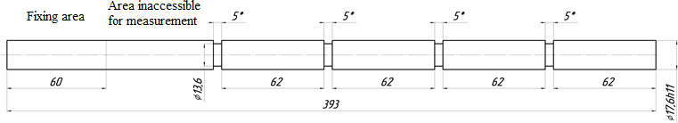

Figure 1 - Dimensions of the workpiece for the experiment:
* - dimensions for reference; unspecified limit deviations – h14, ±IT14/2
To carry out the experiment, a high precision turning and screw-cutting machine of the 16Б16КА model is required. The machine parameters meet the accuracy requirements according to GOST 18097-93 (ISO 1708-8-89). The technical characteristics of this machine allow you to vary the technological parameters in a given range of values: the rotation speed of the workpiece from 40 to 80 m/min, the longitudinal feed rate from 0.1 to 0.5 mm/rev.
As a tool, a turning straight through cutter with a soldered ВК6ОМ hard alloy plate will be used. It has the following geometric parameters of the insert: 5° - front rake angle, 11° - side and secondary relief angles, 91° - plan side relief angle, 10° - plan secondary relief angle, 0°– side rake angle, 1.0 mm – tip radius, 0.05 mm – rounding radius of the main cutting edge.
The control of the quality parameters of the treated surfaces should be carried out with the following instruments: roughness - with a profilometer SJ 201, the magnitude and sign of residual stresses - with an X-ray diffractometer "Dron 4", and microhardness - with a microhardness tester PMT-3M.
The coefficient of efficiency of energy dissipation η is determined by calculation. The values of the quantities that are part of the formula for calculating the specified coefficient are determined experimentally. The main component of the cutting force Pz is fixed using a universal dynamometer УДМ-1200 connected to the ZET 017 spectrum analyzer. The instrument readings will be recorded using a personal computer with the ZETLab application installed in the DC voltmeter mode. The chip shrinkage coefficient kl is determined by the weight method, and the thickness of the plastically deformed transition zone Δx is planned to be determined using an Altami MET 4C metallographic microscope and an Altami UCMOS05100KPA ocular digital USB camera connected to it.
When choosing the factors of the experiment, all the parameters of the cutting process were analyzed, which have the greatest impact on the state of the machined surface. Since the main task of the study is to develop recommendations for the choice of modes for finishing blade machining of alpha titanium alloys, it was decided to take the technological parameters of the

cutting process as factors, namely cutting speed, feed speed and depth of cut. The boundary values of the factors were chosen according to the recommendations [6], as well as according to the catalogs of the most popular tool manufacturers [7, 8].

Table 1 - Numerical values of the experimental conditions

Factors | Main level (x0) | Variation interval | Minimum  value (code 1) | Maximum value  (code 1)
Peripheral speed, m/min,  x1 | 60 | 20 | 40 | 80
Feeding speed, mm/rev,  x2 | 0,3 | 0,2 | 0,1 | 0,5
Cutting depth, mm, x3 | 0,35 | 0,15 | 0,2 | 0,5

Thus, it is planned to conduct a study according to the scheme of a full factorial experiment 2³. The values of the factor levels factors are given in Table 1, the matrix of the experimental plan - in Table 2.

Table 2 - Matrix of the experimental plan 23

№ | x0 | x1 |  | x2 |  | x3 |  | x1x2 |  | x1x3 |  | x2x3 |  | x1x2x3 |  | y
 |  | code | value | code | value | code | value | code | value | code | value | code | value | code | value
1 | 1 | -1 | 40 | -1 | 0,1 | 1 | 0,5 | 1 | 4 | -1 | 20 | -1 | 0,05 | 1 | 2
2 | 1 | 1 | 80 | -1 | 0,1 | -1 | 0,2 | -1 | 8 | -1 | 16 | 1 | 0,02 | 1 | 1,6
3 | 1 | -1 | 40 | 1 | 0,5 | -1 | 0,2 | -1 | 20 | 1 | 8 | -1 | 0,1 | 1 | 4
4 | 1 | 1 | 80 | 1 | 0,5 | 1 | 0,5 | 1 | 40 | 1 | 40 | 1 | 0,25 | 1 | 20
5 | 1 | -1 | 40 | -1 | 0,1 | -1 | 0,2 | 1 | 4 | 1 | 8 | 1 | 0,02 | -1 | 0,8
6 | 1 | 1 | 80 | -1 | 0,1 | 1 | 0,5 | -1 | 8 | 1 | 40 | -1 | 0,05 | -1 | 4
7 | 1 | -1 | 40 | 1 | 0,5 | 1 | 0,5 | -1 | 20 | -1 | 20 | 1 | 0,25 | -1 | 10
8 | 1 | 1 | 80 | 1 | 0,5 | -1 | 0,2 | 1 | 40 | -1 | 16 | -1 | 0,1 | -1 | 8
For each material, a separate test will be carried out according to the same plan as above.
As a result of the experiment, it is necessary to obtain data that make it possible to establish the presence or absence of a correlation between the above-mentioned parameters of the quality of the treated surface and the coefficient of efficiency of energy dissipation. After

that, it will be possible to draw a conclusion about the correctness or fallacy of the hypothesis put forward.
It should be noted that similar studies have already been carried out before. According to the results of the experiment, it was possible to confirm the presence of a correlation between the energy dissipation coefficient and the roughness of the machined surface when turning tool steels [5]. The paper presents the results of an experiment that made it possible to obtain numerical values of the coefficient of efficiency of energy dissipation, according to which graphs of the dependence of this parameter, surface roughness, and cutting temperature on the strain rate were constructed. An analysis of the graphical material showed that there is a possibility of a correlation between the roughness of the machined surface and the coefficient of efficiency of energy dissipation.
The main purpose of the experiment is to test the hypothesis that the conditions leading to the localization of the plastic deformation zone when cutting materials are favorable for obtaining the best quality of the machined surface. If the hypothesis is confirmed, it will be possible to determine the modes of finishing turning of alpha titanium alloys, which will allow achieving the required quality of the machined surface. This will lead to:
- reducing the percentage of defective products made of expensive materials;
- the possibility of controlling the machining process by creating a cutting speed control cycle when machining end, spherical and curved surfaces on CNC machines;
- reduction of time and complexity of finishing operations due to high-quality previous finishing blade processing;
- improving the quality of surface preparation for subsequent welding or coating.
The area of application of the study results extends to machine-building enterprises engaged in the creation of surface and underwater marine equipment and widely using titanium alloys in their manufacture.

References

  - Горынин И.В. Титановые сплавы для морской техники / И.В. Горынин, С.С. Ушков, А.Н. Хатунцев, Н.И. Лошакова. – СПб.: Политехника, 2007. – 387 с.: ил.
  - Prasad Y.U.R.K., Gegel M. L., Doraivelu S. M. Ctal // Metall. Trans. – 1984. – V. 15.
– 1883-1892.
  - Варгасов Н.Р. Оптимизация температурно-скоростных режимов деформирования высокопрочных сплавов по критерию диссипации энергии / Н.Р. Варгасов, В.В. Рыбин // Сб. нучн. тр. / СПбГТУ. – 2001. – С. 10-22.

  - Кремлева Л.В. Методика расчета коэффициента диссипации энергии при резании материалов / К.К. Снегирева, И.В. Ершова // Вестник МГТУ «СТАНКИН». - ФГБОУ ВПО Московский государственный технологический университет "СТАНКИН" №4(31), 2014. – С. 119-122.
  - Кремлева Л.В. Определение оптимальных режимов обработки инструментальных сталей резанием / К.К. Снегирева, И.В. Ершова // Вестник МГТУ «СТАНКИН». - ФГБОУ ВПО Московский государственный технологический университет "СТАНКИН" №1(32), 2015. – С. 38-40.
  - Кривоухов В.А. Обработка резанием титановых сплавов / В.А. Кривоухов, А.Д Чубаров. – Москва, 1970. – 180 с.
  - Обработка титана: Техническое руководство. SANDVIK Coromant [Электронный ресурс] // AB SANDVIK Coromant. 2011.12. - 136 с. - Режим доступа: https://www.manualsdir.ru/manuals/407510/sandvik-coromant-obrabotka-titana.html.
  - Обработка титана: Справочное руководство ISCAR. [Электронный ресурс] // Iscar Ltd. 2013 – 57 с. - Режим доступа: https://www.iscar.ru/Catalogs/publication- 2019/machining_titanium_rus_metric.pdf
Fomin Evgeniy Vladimirovich - candidate Sc. of Engineering, head of the sub-department of Metal Technology and Mechanical Engineering of Northern (Arctic) Federal University named after M.V. Lomonosov.
E-mail: e.fomin@narfu.ru
Snegireva Ksenia Konstantinovna - graduate student of Northern (Arctic) Federal University named after M.V. Lomonosov.
E-mail: k.snegireva@narfu.ru

УДК 621.7:620.1
Zhukov S.V., Sterlin A.Y., Suminov I.V.

Technology of polymer-metal oxide composites for adaptive protection against setting and jamming during friction on the example of antifriction layers obtained by plasma- electrolytic treatment of cylinders of a modulator of high-energy acoustic radiation.

The article discusses the technological aspects and results of the application of plasma- electrolytic treatment for the creation of adaptive composite coatings on the surface of high- precision components, elements of devices and sensors in conditions of high-frequency oscillatory loads between touching surfaces.

Keywords: Plasma-electrolytic treatment, plasma-electrolyte synthesis, microarc oxidation, adaptive materials and coatings, antifriction coatings, antifriction layers, wear resistance.

The most effective engineering solutions and advanced technologies are increasingly provided by scientific discoveries and experimental development of adaptive materials, in particular, capable of changing the properties and friction conditions, inhibiting the mechanisms of electrophysical and electrochemical wear processes, and matching the properties and interaction of polymers, metals and oxide ceramics in high-precision mates.
In this paper, using the example of cylinders of a high-energy acoustic radiation modulator made of a polymer-metal oxide composite obtained on the basis of plasma-electrolyte processing technology, the technological aspects of the creation and results of research and testing of polymer-metal oxide composites providing adaptive friction conditions and protection against setting and jamming are considered. .
A typical device for a high-energy acoustic radiation modulator is shown in Fig.1. The compressed gas enters the pre-chamber through the filter, from where it exits through the valve assembly into the neck of the docking with the horn [1].
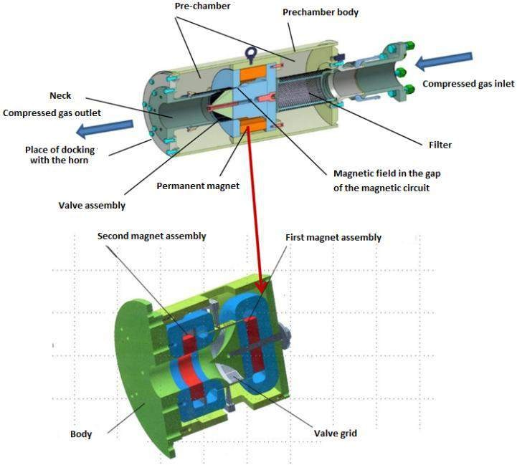
Fig. 1. Typical device of a modulator of high-energy acoustic radiation

The function of a valve that modulates the gas flow is performed by cylinders (Fig. 2), which, when mutually moving by means of an electromagnetic propulsor, throttle the gas flow through overlapping gratings located on the forming part. By achieving a certain degree of overlap (amplitude, frequency, pulse duty cycle), a random acoustic signal of a given spectral density is generated. Accordingly, the achievement of the highest quality indicators (quality factor, acoustic efficiency and modulator resource as a whole), in terms of mechanical design, all other things being equal, depends mainly on minimizing gas flow along the axis of the cylinders (or sliding fit accuracy) between the cylinders and reducing vibration excitation losses (or losses to overcome friction forces).

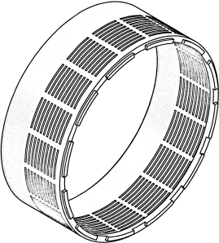  A) Sketch of the inner cylinder | 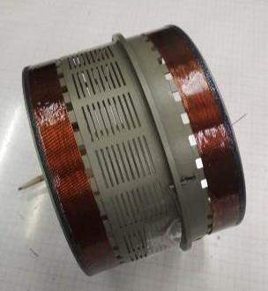  C) Photo of cylinders assembled with electromagnetic windings
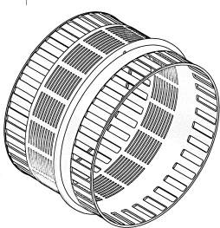  B) Sketch of the outer cylinder | 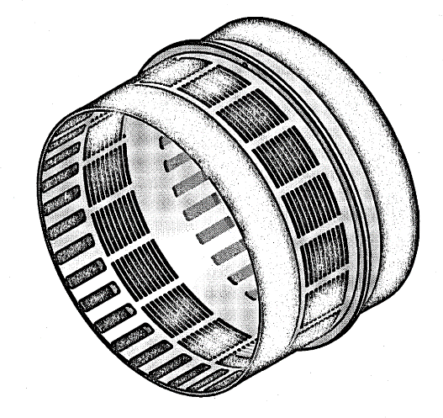  D) Sketch of the cylinders assembled
Fig. 2. Cylinders of the valve assembly of the modulator of high-energy acoustic radiation

The experience of using such valve designs has identified problems related to the design and materials from which the cylinders are made. The best combination of a set of characteristics (thermal expansion, minimum material density, minimum friction force, rigidity, wear resistance, continuous operation resource, manufacturability, ensuring the required accuracy, limiting operational deviations of dimensions and quality parameters) relative to the applied ceramic, steel and aluminum with sprayed, deposited and diffusion coatings, have cylinders made of aluminum alloys with anodic oxide films obtained by hard anodizing. Other materials have not yet found application due to the specifics of the necessary structural massiveness, consuming high energy capacities and having a parasitic inertia of the modulator excitation, as well as due to high pressures and temperatures [2].
The main problem of using cylinders made of aluminum alloys is shape relaxation, a progressive increase in friction forces and surface wear with increasing frequency of movement and temperature. This causes a low resource and continuous duration of work, dynamic narrowing of the range and a decrease in the maximum achievable frequencies of the modulator. In addition, the cyclic mode of operation leads to fatigue defects and local damage in the form of scratches (bald patches) and delamination of coatings due to the occurrence and release of shear stresses and the accumulation of residual stresses. The use of anodic oxide coatings, antifriction inserts, and lubricants somewhat (up to 7%) increase the service life, but lead to pollution of the wave paths and do not solve the problem of low continuous operation time and valve jamming [3].
As an alternative solution, an adaptive polymer-metal oxide composite (PMOC) is proposed, made on the basis of plasma-electrolyte processing (PEP), which provides plasma electrochemical synthesis of materials, the composition and structural features of which are formed from the components of the processed material and electrolyte. This allows you to modify the volume of the metal surface, i.e. create a new physical surface by synthesizing polymers, metals and their oxides in an electric plasma discharge, giving it a complex of unique properties that is unusual for other options.
An aluminum alloy (Al-Cu-Mg-Li) is chosen as the structural basis of adaptive PMOCs, and the adaptive functions of resistance to changing conditions during valve operation (increased wear and friction forces) are provided by a polymer-metal oxide surface newly synthesized in an electrolyte plasma, which has adaptive anti-friction properties :
- inhibitory processes of wear and friction by heterogeneous modifications of high- temperature oxides, mainly complexes of aluminum α-Al2O3 (29-38%) and silicon SiO2 (up to 15%) with higher allotropic modifications of spinels formed from the main substances of plasma sources, such as Al2SiO5 (27-34 %), Al2CuO4 (3-9%) and inclusions that increase the surface

distribution density of Mg(AlO2)² and LiAlO2 spinels milled in the process of plasma nodulation centers up to 3% in total, and intermetallic compounds Al2Cu and Al3Li, in unpredictably low concentrations (up to 2 %), providing stationary electrical resistance and thermal conductivity in the range of operating temperatures;
- reducing friction forces and wear processes with an antifriction agent (tetrafluoroethylene copolymer with ethylene), which, under the action of thermal expansion forces, leaves the activated mesoporous structure of the matrix at the level of several monomolecular layers in the plane of worked-in (self-rubbed) grains and crystals of the sliding surface.
During the development of the technological process of manufacturing adaptive PMOCs, the ranges of permissible deviations of the structural dimensions of the cylinders were established (within the tolerance field of 3...7 µm), the technology of manufacturing PMOCs cylinders consisting of an aluminum structural base with a modified surface (metal oxide matrix) filled with an ethylene copolymer of tetrafluoroethylene was developed, the structure and element-phase composition, and a test stand-demonstrator (modulator mock-up) with PMOC cylinders was also manufactured.
Figure 3 shows the photos of the PMOC obtained with a FEI Quanta 600 FEG scanning electron microscope at various magnifications.
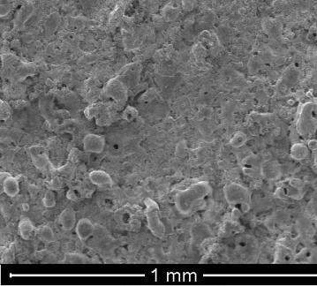
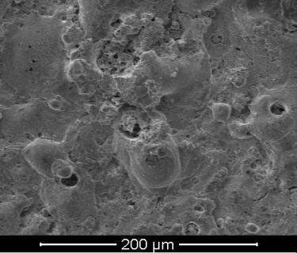

A) General view of the surface after PEP.

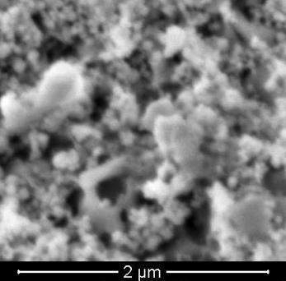
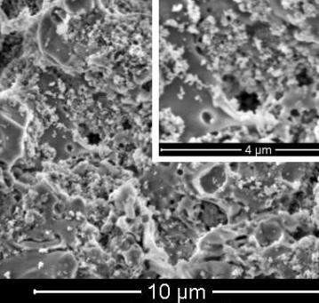

- View of pores filled with tetrafluoroethylene copolymer.

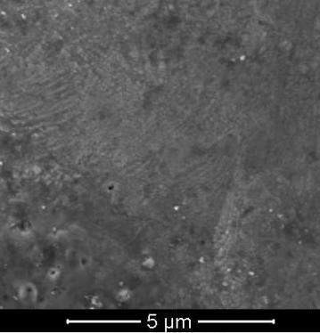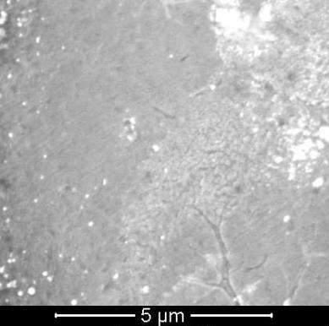

- Types of surface after processing
Fig. 3. SEM photos of the cylinder surface
Figure 4 shows a schematic model of the distribution of phase composition and microhardness on the transverse oblique sections of the surface of the PMOC layers, based on the results of: layer-by-layer phase analysis using the ARL9900 Intellipower Workstation X-ray diffractometer and microhardness measurement by the Vickers method at a load of 1.0 N on the DM-8 Affri microhardness meter.

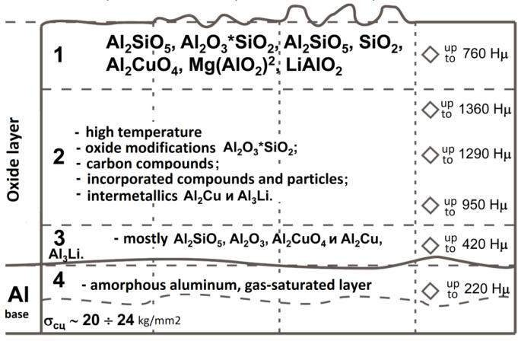

Fig.4. Schematic model of the distribution of the phase composition and microhardness of the PMOC layers. The conditional layers are marked: 1 – outer lapped layer; 2 – main working layer; 3 – transition layer; 4 – base material

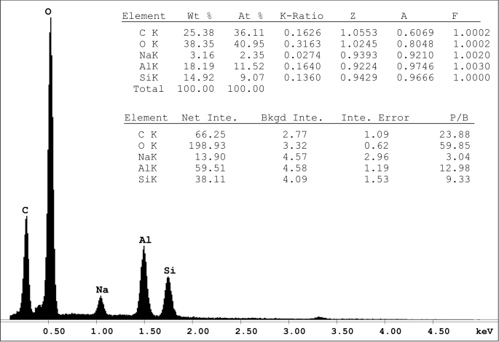
Figure 5 shows the spectrum and the gross chemical composition obtained on the area of an oblique (25°) transverse section of the surface etched by an ion beam using the EDAX unit of the Quanta 600 FEG scanning electron microscope.
Fig. 5. X-ray spectral analysis of the area of the oblique (25°) transverse section of the
PMOC surface

Figure 6 shows the electrical circuit of the modulator drive and a photo of the assembly of the demonstrator.
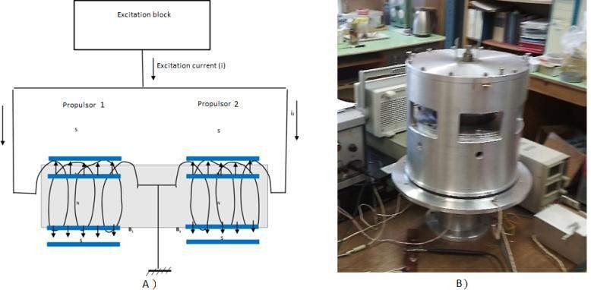
Fig.6. The electrical circuit of the modulator drive (A) and a photograph of the assembly
(B) of the demonstrator

The ranges of permissible deviations of the structural dimensions of the cylinders are determined taking into account mutual deformations that establish a gap (up to 14 µm) between the cylinders under the influence of extreme temperatures, pressure pulsations and gas flow that occur during operation. This served as the initial data for the assignment of tolerances and allowances for the machining of the metal base of the cylinders and the technological parameters of plasma-electrolytic processing, providing synthesis conditions.
The technological process of obtaining adaptive PMOC was carried out at the laboratory and industrial installation of the Center for Plasma-electrolyte Technologies of "MSUT "STANKIN". A typical installation diagram is shown in Fig. 7.

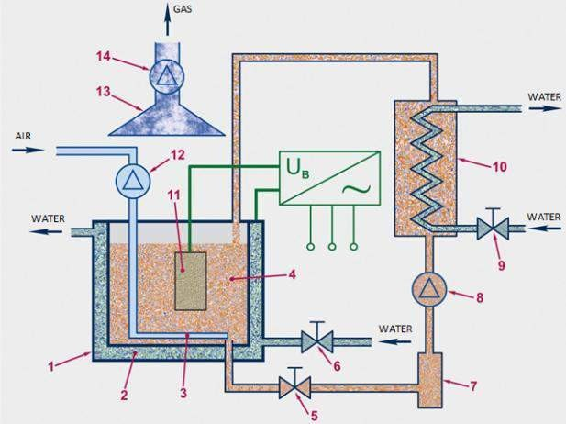
Fig. 7. Composition of the PEP installation: 1 – electrolyte bath; 2 – water cooling jacket; 3
– bubbler; 4 – electrolyte; 5, 6, 9 – shut–off valves; 7 – filter; 8 – water pump; 10 – tank with heat exchanger; 11 - detail; 12 – air compressor; 13 – exhaust hood; 14 – exhaust fan

Basically, the equipment for electrochemical processing (Fig. 7) consists of an electrolyte bath or several baths (1), a technological current source, cooling and mixing systems (3, 12) of the electrolyte and exhaust ventilation (13, 14). The electrolyte cooling system may consist of devices for pumping (5, 7, 8, 10) the electrolyte and/or cooling (2, 6, 9) the bath jacket. In the tank 10 of the electrolyte pumping system there is a heat exchanger for cooling this electrolyte. Mixing of the electrolyte is realized either by blowing air through the electrolyte – by bubbling (Fig. 1, pos. 3, 12), or by mechanical stirring using a stirrer – motor with an impeller mounted on the shaft (not shown in Fig. 7).
The main established technological parameters of the process for obtaining PMOC at different stages include:
- electrical mode of initiating plasma discharges - combined symmetrical pulse anode- cathode with the end of the anode half-cycle on the decline and sequential anode pulse;
- total duration of the process - 150 minutes;
- current density – 4…35 A/dm²;
- electrolyte composition - silicate-alkaline aqueous solution-suspension of aluminates (up to 2.5%) and ethylene copolymer of tetrafluoroethylene (0.5-5% depending on the stage) with surfactants (up to 0.1%);
- electrolyte temperature – 20…60°С.

The complex of these technological devices and variable parameters ensures the flow of several main stages-processes:
- preliminary (primary) substitutional activation of the surface, through which the problems of creating conditions for the plasma-electrolytic transformation of the crystal lattice of the grains of the metal being modified into a submicrodispersed amorphous-crystalline structure of the porous metal oxide layer (electrode material), which is the nodal source of substances (in particular, the donor of metal cations in synthesis), forming oxide layers of the composite;
- synthesis of a functional polymer-metal oxide composite in the volume of a new physical surface (matrix), based on activated metal oxide and synthesizing crystalline hydrates from the formed substrate of charged dissolved, colloidal and suspended substances - electrolyte aggregates contracted by electromagnetic field strength lines, and incorporating neutral diffusely distributed copolymers in electrolyte;
- final plasma-electrolytic activation and electrophoretic filling of the mesopores of the metal oxide composite matrix with aggregated surfactants in an electric field and compounds with an ethylene copolymer of tetrafluoroethylene, which provides an adaptive function of reducing friction forces with increasing temperature.
The stages of synthesis and the structure of the antifriction layer can also be considered within the framework of the general analogy of model representations [4, 5].
The following conclusions can be drawn from them.
- The formation of the outer layer of PE coatings proceeds mainly due to the removal of aluminum oxide melt to the surface of the coatings with the effect of a large amount of vapor-gas phase on it after the extinction of micro-discharges in the through transverse pores of the coatings.
- The formation of the inner layers of PE coatings proceeds by two mechanisms. The first is the formation of aluminum oxide melt and its removal not to the surface of the coating, but the filling of a number of pores in the inner layers and the adjacent part of the volume of the outer layers of coatings after the operation of anode plasma micro-discharges under the outer layers of coatings. The latter is realized due to the ignition of micro-failures in the anode "half-life", when the anode voltage does not reach maximum values. The second one is based on the mechanism of convective diffusion transfer of aluminum and oxygen ions through molten local areas of the inner layers of coatings adjacent to high-energy plasma micro-discharges. The latter are realized in the transverse through pores of coatings to the greatest extent at amplitude stresses. The second mechanism of growth of the inner layers of PE coatings prevails after a significant reduction of pores in the inner layers.

- The reason for the absence of a change or a slight change in the dimensions of the samples with an intensive increase in the thickness of the coatings from about 50 - 80 µm is the consumption of aluminum not only for the growth of PE coatings, but also for filling voids, transverse pores, especially in their inner layers.
- A significant change in the given current density during the plasma-electrolytic processing (PEP) of the D16 alloy according to the mechanisms of oxidation of the metal base leads only to an increase in the growth rate of coatings, but not to a change in the intervals of coating thicknesses, in which the mechanisms of their formation change. It is shown that in order to obtain a wear-resistant anticorrosive inner layer of coatings, PEP processes at all given current densities (15–45 A/dm2) should be carried out up to a thickness of at least 80 µm.
Table 1 presents the achieved physico-chemical characteristics of the obtained PMOC, including the data given in the sources [4, 6-8].

Table 1. Obtained physicochemical characteristics of PMOC.

№ | Name |  |  | Characteristics
1 | Phase composition
 | matrix components: |  |  | - α-Al2O3 - 30 … 60%  - SiO2 - 20 … 50 %  - Al2SiO5 - 5 … 70 %
 | components introduced compounds: | of bonds elements | and and | - oxides of impurities - up to 5%  - коллоиды  - colloids
2 | Density, g/cm³ |  |  | 3,2 – 4,1  porosity) | (adjustable, taking | into | account
3 | Operating temperature range: |  |  | - operating time up to 10,000 hours - from -50°С to +300°С (in air).  - operating time up to 100 hours - from -50°С to 350°С (in air).  - thermal shock up to 12-15 s/mm³ - up to 2500°С (in air)
4 | Destructuring temperature (phase transition of the most fusible component) |  |  | from 250°C to 2000°C.
5 | Thermal conductivity |  |  | - at 300K - from 35 to 40 W/m*K;  - at 700K - from 11 to 15 W/m*K.

6 | Heat capacity | 55 – 79 J/mol*K.
7 | Thickness | up to 250 µm
8 | Microhardness | from 700 to 2500 HV (in some cases 4500)
9 | Adhesion strength | At the level of the base material, up to 35 kg/mm2
10 | Electrical strength | - at a thickness from 1 to 10 µm – up to 200V/µm  - at a thickness from 70 to 100 µm – up to 30V/µm  - at a thickness from 150 to 200 µm – up to 22 V/µm
11 | Dielectric capacity | From 2 to 50
12 | Resistivity at thicknesses of 50 - 250 µm | from 0.1 to 18.1 МОm*m.
13 | Dielectric loss tangent | from 0.017 to 0.730
14 | Through porosity | 0.5 to 50%
15 | Friction coefficient (best result without erosion and wear): | PEO-coating/PEO -coating – 0.004-0.01;  - coating/steel 45 - 0.009 - 0.012;  - coating/aluminum D16 - 0.07 - 0.1;

The mechanism of operation and efficiency, previously studied on the samples, are generally characterized by the fact that during the initial output to the specified frequencies (from 70 to 1500 Hz), the surface is run-in (up to 31500-42000 cycles of reciprocating motions) with the waste output (up to 12% from the synthesized mass). After that, as the surface is rubbed (up to 200,000-600,000 cycles of movements in the frequency range from 300 to 1500 Hz), the output of wear products decreases (to less than 0.01% of the synthesized mass). At the same time, radial stresses and contact loads are reduced to a greater extent due to their distribution over an increasing area of the contact surface. This happens up to values corresponding to the specific shear force of polymer-oxide bonds (less than 0.01 kg/mm2), provided by the established sizes of monomolecular layers of tetrafluoroethylene, which stretches with increasing temperature from the mesoporous structure of the composite under the action of surface tension forces of the copolymer, manifested in electret and mechanical and chemical effects [9, 10].
The values of normal loads on rubbing surfaces are determined by the stresses (external gas pressure) and the forces caused by the deformation of the cylinders from hereditary stresses and released during operation. The values of normal loads are determined by the range of displacement forces and the wear area of the contact pads (in the range of 21.8 to 31.6 cm²),

which was established in the ranges of 0.15 - 0.35 MPa, taking into account the variable gas pressure P (from 0.028 to 0.07 kg/m2) and the difference in the average value of the pulsation pressure.
The graph (Fig. 8) shows the dependences of the adaptation of the functions of the characteristics of friction stresses and temperature on the duration (the number of motion cycles at a frequency of 1250 Hz), which are also valid in the continuation of the operating time. With an increase in load with a step of 1.5 times, the friction coefficient grows within 20% of the initial value and, up to the operating time of more than 150 million cycles, tends to values in the range from 0.009-0.011. Further operating time (over 175 million cycles at frequencies of 800 - 1500 Hz) for unknown reasons is not accompanied by significant wear and load changes.
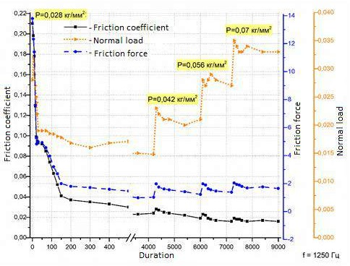
A) adaptation of friction conditions

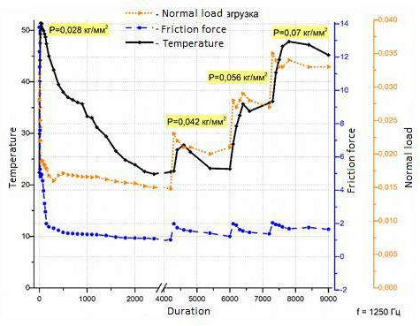

B) adaptation of temperature factors
Fig.8. Friction coefficient (A), temperature (B) and measured axial displacement force at
frequency f=1250 Hz and oscillation amplitude Δl=0.9 mm) and when pressure P changes during the test

Additionally, it is worth noting the following.
- In a comparative assessment of the characteristics of cylinders with PMOC coatings and fluoroplastic slimes, the friction forces of the latter exceeded the PMOC by more than 2.5 times.
The critical value of excess pressure (over 1.5 kg/ mm2) leads to an increase in friction forces exceeding the straining forces developed by the electromagnetic propulsion. At the same time, in the initial run–in time, local loads could reach 7-10 kg/mm².
Thus, in the course of developing the technology for the formation of a polymer-metal oxide composite, the following tasks were solved:
- creation of a solid crystalline hydrate and metal oxide layer (electrode material), which is the nodal source of substances for synthesis in electrolyte plasma, which ensures the formation of adaptive polymer-metal oxide composite layers (coatings);
- inhibition of friction processes leading to wear by blocking the main conditions for their occurrence;
- formation of a composite by controlling the parameters of the plasma discharge, which forms the conditions for the synthesis of adaptive anti-friction surfaces.

Conclusion
In the field of plasma-electrolyte processing, very extensive research and development work is currently underway in the following areas:
- transformation of the crystal lattice of metal grains (and their alloys) into amorphous- crystalline structures with the participation of donors of ion-covalent bonds obtained by plasma formed between the metal and the crystal hydrate (solid electrode) at the metal-oxide-electrolyte interfaces at high cooling rates;
- synthesis of electret structural materials and metal oxide composites on functional surfaces;
- plasma-electrolyte modification of organic hydrocarbon materials, selective replacement of hydrocarbon compounds of biological materials with organosilicon ones (aluminosilicate, phosphosilicate, etc.);
- transition-switching construction and structuring of thermoelectric materials;
- transformation of the composition and structuration of the surface of porous and coarse- grained metal oxide materials obtained by additive sintering and high-energy fusion;
- treatment of aqueous solutions (deionization, separation, desalination and compaction).
The most promising in the area of experiments under consideration are the following studies:
- study of the effect and dependence of the change in the electrical resistance of friction pairs from metal oxide layers (PMOC) on the energy flux density of mutual displacement under variable mechanical and thermal deformations, which can open up the possibility of implementing self-diagnostic functions (strain-resistive) in such systems, as well as controlling frequency-resonance natural oscillation functions of such valve assemblies;
- studies of the influence of electrostatic and electrostrictive effects on changes in the friction conditions of polymer-metal oxide layers during the application of electric fields;
- studies of weight reduction, wear, inertia and resistance moments of mechanical control systems using new samples of low-torque spherical bearings and plain bearings, based on polymer-metal oxide composites, in order to improve the technical and economic characteristics of devices and aircraft.
The team of authors is very grateful to colleagues who develop the depth of subtleties of electrical and physico-chemical effects in this area of research.

References

- Pat. RU2707587C1 Russian Federation, IPC G10K 7/06 (2006.01). A method of generating sound for testing structures and a device for its implementation / Sterlin A.Ya., Furman A.V., Kim S.K., Kutsenko S.A.; Published: 28.11.2019 Byul. No. 34. - 15 p. : ill.
- Sterlin A.Ya. The principle of constructing high-frequency sound modulators for acoustic tests for the strength and service life of aircraft. Factory laboratory. Diagnostics of materials. 2020;86(11): pp.60-66.
- Zhukov S.V., Sterlin A.Ya., Suminov I.V. Technology of transformation of the atomic- crystal lattice of metal alloy grains into amorphous-crystalline structures of metal oxides (with the participation of donors of ion-covalent bonds of solutions) formed between metal and crystallohydrate (solid electrode) at the metal-oxide-electrolyte interface in electrolyte plasma. Materials of the reports of the "V-National Competition of innovative projects of the aerospace industry". "Central Aerohydrodynamic Institute named after Professor N. E. Zhukovsky", VUZPROMEXPO, December 10-11, 2020. Moscow: VUZPROMEXPO, 2020– - 9s.
- Suminov I.V., Belkin P.N., Epelfeld A.V., Lyudin V.B., Krit B.L., Borisov A.M. Plasma-electrolytic modification of the surface of metals and alloys. In 2 volumes. Volume II. - Moscow: Technosphere, 2011. - 512 p.
- A.G. Rakoch, Z.V. Khabibullina, O.V. Volkova, A.V. Borko, Tran Van Tuan, I.V. Suminov and S.V. Zhukov. Influence of current density and duration of PET of AA2024 alloy on the rate and growth mechanisms of a wear-resistant anticorrosive coating inner layer. Int. J. Corros. Scale Inhib., 2021, 10, no. 4, P.1621–1637.
- Zhukov S.V., Suminov I.V., Epelfeld A.V., Zheltukhin R.V. Investigation of the effect of MDO-processing on the mechanical characteristics of aluminum alloys during tensile tests. Pech. Quick-hardened materials and coatings. Proceedings of the 5th All-Russian Scientific and Technical Conference with International participation. December 12-13, 2006 "MATI" - K.E. Tsiolkovsky State Technical University.: Collection of works.. M.: MATI, 2006– - 5s.
- Zhukov S.V., Kantaeva O.A., Zheltukhin R.V., Epelfeld A.V., Ber L.B. Investigation of physical and mechanical properties, structure and phase composition of coatings obtained by microarc oxidation. Instrumentation. No. 4, 2008. pp. 28 - 32.
- Zhukov S.V., Suminov I.V., Zheltukhin R.V., Fomichev A.A., Epelfeld A.V., Epelfeld
I.V. Study of wear resistance of MDO coatings on aluminum. Scientific works of MATI. Issue 14 (86). - Moscow: IC MATI, 2009. pp. 206-212.
- Ryzhkiv A.A., Burlakova V.E. On electrical phenomena in friction. Technical sciences. Bulletin of the DSTU. 2011. Vol.11, No. 9(60), pp. 1564-1573.

- Lukashev E.A., Sidorov M.I., Yurtsev E.S. Some aspects of electrochemical representation of wear processes in tribology. Modern Materials, Equipment and Technologies, No. 2 (10), 2017. pp. 90-98.

Zhukov Sergey Vladimirovich, Candidate of Technical Sciences, Associate Professor, Head of the laboratory of the Moscow State Technological University "STANKIN".
E-mail: ser.zh82@mail.ru

Sterlin Andrey Yakovlevich, Ph. D., chief scientific officer SSC FSUE "Central Aerohydrodynamic Institute named after Professor N. E. Zhukovsky".
Tel: +7(903)716-59-55.

Suminov Igor Vyacheslavovich, doctor of technical Sciences, Professor, Director of the center for new materials and technologies FGBOU VO "Moscow state technological University "STANKIN".
E-mail: ist3@mail.ru

УДК 621.735.016.2
Panfilov P.V.

Module for rapid prototyping of mechatronic device control
The description of the module for rapid prototyping of electronic components of mechatronic devices is given. The module is based on the STM32F103CBT6 microcontroller, and includes sensors and actuators that are relevant for mechatronic devices and robots. Two ways of program support of the module are described.
Keywords: mechatronic device control, microcontroller, Cube IDE.

Currently, microcontrollers (MC) are widely used in complex technical systems containing electronic control modules, from toys, household appliances, cars, to spacecraft and robots. The role of the MC in robotics and mechatronics is great, due to the ease of reprogramming, simplicity of equipment design, versatility of application and small dimensions with large computing resources.

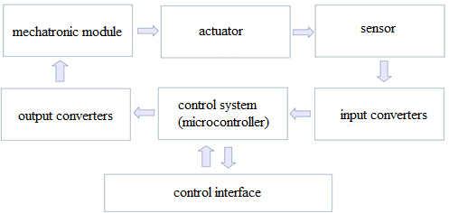

Fig. 1: Typical mechatronic system
A mechatronic system is a single complex of electromechanical, electrohydraulic, electronic elements and computer equipment, between which there is a constant exchange of energy and information, united by a common automatic control system (possibly with elements of artificial intelligence) [1]. The composition of the components of a typical mechatronic system is shown in Fig.1. The control system of such a system can use MC. In a mechatronic system, three main components are simply distinguished: mechanical, electronic and informational, the totality of which forms the system as a whole [2]. Electronic and information parts are important elements of the system, without which its operability is impossible.
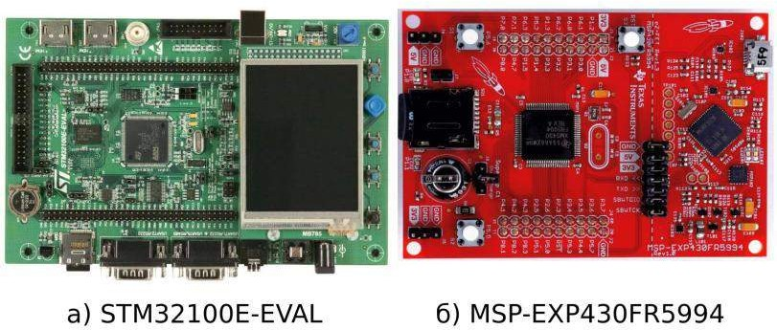
Fig. 2: Examples of developer boards
When developing a mechatronic system at the prototyping stage, it is required to quickly develop the electronic part of the system and software to check the operability of the entire system and achieve the required technical characteristics. At the same time, microcontrollers are often used for simple mechatronic systems. To facilitate this process, foreign firms produce

special developer boards. They allow you to quickly check the ideas embedded in the designed module. Figure 2 shows two examples of such boards from foreign manufacturers.
It should be noted that usually such boards are made universal enough that they can be used for various applications. This is often not very convenient and does not always allow them to be used for mechatronic systems without additional external electronic components, and this complicates their use.
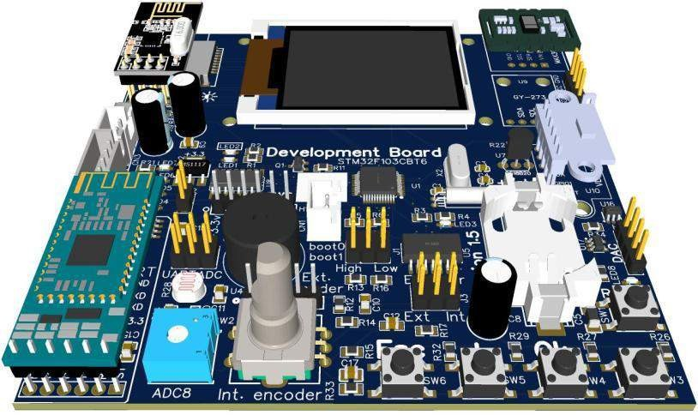
At the department of robotics and mechatronics of MSUT “STANKIN”, a special microprocessor module was designed and manufactured for prototyping control systems for mechatronic devices, taking into account the specifics of their use in robotics. The developed module allows for the rapid development of mechatronic devices and can be used as a hardware part for bachelor's and master's theses.
Fig. 3: 3D model of the module for prototyping mechatronic devices
The layout is based on the STM32F103CBT6 microcontroller (Fig. 3), which has many peripheral devices “on board” and allows them to be used in the development of mechatronic devices.
In addition to the microcontroller, the following peripherals are installed in the layout:
- color TFT display with a resolution of 128x160 pixels, using the SPI interface controller ST7735;
- microsd card connector (for connection with the MC, the SPI interface is used);
- radio interface based on the NRF24L01 chip;
- reset button;

- 4 analog buttons and 3 LEDs;
- mechanical encoder with duplication of pins on a separate connector;
- - swd programming connector with additional swo output;
- clock quartz for internal clock STM32F103 powered by battery;
- variable resistor connected to analog input STM32F103;
- photoresistor connected to analog input STM32F103;
- ds18b20 temperature sensor;
- instead of two analog inputs, you can configure jumpers and use hardware uart2 STM32F103;
- distance sensor on the VL53L0X chip;
- magnetic field sensor on the HMC5883L chip;
- i2c interface connector, for connecting additional devices;
- stepper motor control unit based on uln2003 chip;
- current sensor for measuring the current consumption by a stepper motor on an ACS70331 chip;
- micro usb connector for VCP or MSD.
Two approaches can be used to work with the module. The first is programming in the Arduino IDE, the second is using professional programming environments such as Cube IDE.

Using the Arduino IDE environment.
In this variant, you can use the Arduino IDE environment by installing the Leaf Maple mini board through the board manager and writing a special loader to the layout. Using the MC STM32F103CBT6 allowed hardware emulation of the Leaf Maple mini board, and this makes it possible to use the software of the stm32duino project [3].
After writing the Leaf Maple Mini loader to the layout, it becomes possible to download software via a USB port, as is done in the Arduino IDE. The download is performed in DFU mode, which requires the installation of VID_1EAF&PID_0003 drivers. When connected, the board is detected by the system as a COM port, but in the firmware download mode it switches to DFU mode.
Using this approach gives a low threshold for entry into MC programming, because the work is carried out in the Arduino environment, and, accordingly, the entire knowledge base that was accumulated by the community earlier "works", and many libraries and codes developed for Arduino boards will work. At the same time, the development of the mechatronic system will be carried out with a modern 32-bit ARM microcontroller having a clock frequency of 72 MHz, a flash memory capacity of 128 KB and RAM of 20 KB, which is much more powerful than the "classic" Arduino. Significant performance and high frequency make it possible to solve more

time-consuming tasks such as digital signal processing (DSP) and real-time control of complex objects.
When programming in the Arduino environment, the module allows you to use three ways to receive information from the mechatronic system (feedback of the human-mechatronic system interface).
- Three LEDs that can be used to indicate various events and the status of the program. This is a classic way to display the device status in the MC.
- In the Arduino environment, you can use the standard way to output information - a virtual serial port, using the Serial.print method.
- Displaying information on the display, which is soldered on the layout. Color display with a resolution of 160*128 pixels, there is a display support library. When using this library, the developer will not work with display commands, but with graphic primitives such as a line of text, lines, points, rectangles, etc.)
Several options can also be used as controls in the module.
- Using the standard way of the Arduino environment - virtual serial port, using the Serial.read method.
- Incremental encoder with button. This is a very convenient way to enter. Rotation of the encoder gives a change in the edited parameter or a change in the menu item, and clicking on the encoder fixes these changes.
- Four analog buttons that use one analog input and a resistive divider, pressing the button changes the voltage at the analog input, the level of which corresponds to a specific button.
The module has several sensors and outputs for actuators, which are relevant in the design of robotic and mechatronic systems.

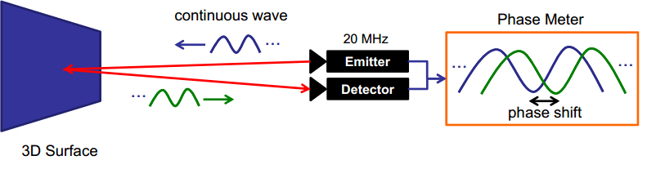
Fig.
4: Operating principle of Time-of-Flight rangefinder

The VL53L0XV2 is the smallest laser rangefinder available today. It uses patented Time- of-Flight (ToF) technology. The sensor provides accurate distance measurement regardless of the reflectivity of the target up to 2000 mm with a resolution of 1 mm. The sensor error is ± 3%. The beam is invisible to the human eye. All measurement readings can be obtained from the sensor via the I2C interface, which is also used for sensor settings.
The method of measuring distance is phase [4]. The principle of operation of the Time-of- Flight of such a rangefinder is illustrated in Fig. 4. The laser constantly emits a luminous flux, which is modulated with a frequency approximately equal to 500 MHz. The phase laser rangefinder does not change the wavelength of the laser itself, but only modulates it. The reflected beam is received by a photodetector, and its phase is compared with the phase of the emitted laser signal. Since the light has a known propagation speed, when the beam returns, a phase shift is formed relative to the emitted signal, after which the device calculates the distance. The laser emitter operates in the range of 940 nm.
The second interesting sensor installed in the module is a three-axis digital compass (magnetometer) built on the HMC5883L chip, also operating on the I2C bus. Three magnetoresistive sensors are used as sensors in the chip. The developer is Honeywell [5]. The sensitivity of the sensor is 5 milligauss.
In the absence of external interference and when the sensor is positioned in a horizontal plane, the projection of the magnetic induction vector on the XOY plane will point to the north. This sensor can be used as an electronic compass, which is especially important for mobile robots.
The module provides the ability to switch from an installed mechanical encoder, which is used as a control, to an external optical incremental encoder. Such sensors are widely used in robotics to track the angle of rotation of various mechanisms or the movement of their parts relative to each other. To process the encoder signals, a hardware timer MС STM32F103 [6] is used, and this allows you to suppress the “bounce” of contacts at the hardware level and not use the MC computing core to count control pulses. The use of a hardware timer makes it possible to

connect optical rotation angle sensors and optical rulers with high resolution to the module and use it as a motion controller.
As part of the module design, libraries for Arduino were found on the Internet and finalized or developed for the entire installed peripherals of the layout. The use of these libraries will allow the developer not to do routine work on programming a specific sensor (working with registers and memory), but to immediately switch to programming functionality and using fairly complex sensors in practice, which reduces development time.

Using the Cube IDE environment
Using this approach allows you to use professional MC programming tools such as Cube IDE (Fig. 5), IAR Embedded Workbench EWARM IDE or Keil MDK-ARM uVision IDE when developing software for the module. At the same time, an in-circuit programmer/debugger ST- Link can be connected to the module with the possibility of using an additional SWO line to transmit text messages to the console. All interaction with the layout in this case occurs through it.
Using the ST-Link in-circuit programmer/debugger allows you to load the created code into the MC, do step-by-step code execution, set breakpoints and view the value of registers and
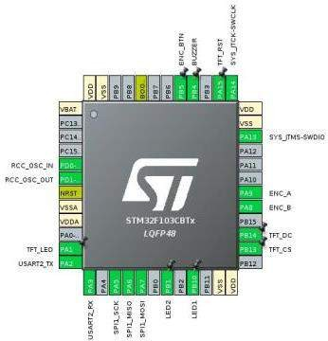
variables. Using a debugger dramatically increases the convenience of debugging code and finding errors in it.

Fig. 5: Configuring the MC in CubeMX
As part of the module design, code has been developed in the Cube IDE for full testing. By uploading this code to the microcontroller, you can test all the components of the layout and determine their operability. This software is convenient to use when mounting layouts as an output control, or as a working example for working with the hardware of the layout.

Since the MС STM32F103 has quite large amounts of memory and computing resources, it is possible to use an operating system (OS), for example, FreeRTOS, when developing code. FreeRTOS is an open source operating system. You can download the latest version absolutely for free and without any problems. This OS is written in C with the inclusion of small assembler

inserts. In the Cube IDE environment, this operating system is a built-in component, and it can be easily used.
Summing up, we can say that the developed module allows the rapid development and prototyping of mechatronic systems. This module can be used as a control system (see Fig.1.) of a mechatronic system or a separate robot node. The wide functionality makes it possible to use the built-in and/or connect external peripherals. At the same time, you can use both simple programming tools like Arduino IDE and professional ones like Cube IDE, using all the tools of a professional such as real-time operating systems and a debugger. All information about the developed module (diagrams, photos, libraries and developed software for testing) is publicly available on github [7].

References
- Gotlib B.M, Vakalyuk A.A. Introduction to the specialty "Mechatronics" and robotics. -
Yekaterinburg: Publishing House of UrGUPS, 2012 .-- 136 p.
- Egorov O.D., Poduraev Yu. V., Buinov M.A. Robotic mechatronic systems. - M.: MSTU "Stankin", 2015. - 326 p.
- Arduino STM32 (stm32duino project), - Available at:: https://github.com/rogerclarkmelbourne/Arduino_STM32.
- VL53L0X World's smallest Time-of-Flight ranging and gesture detection sensor (Datasheet - production data) - Available at:: https://www.st.com/resource/en/datasheet/vl53l0x.pdf
- Three-Axis Digital Compass IC HMC5883L Honeywell - Available at: http://www.farnell.com/datasheets/1683374.pdf
- AN4013 Application note: STM32 cross-series timer overview - Available at: https://www.st.com/resource/en/application_note/dm00042534-stm32-crossseries-timer- overview-stmicroelectronics.pdf
- Information about the prototyping module for mechatronic systems. - Available at: https://github.com/pav2000/DevBoardSTM32F103CBT.

Panfilov Pavel Vladimirovich, - candidate Sc. of Engineering, assistant professor of the sub-department of"Robotics and Mechatronics" MSUT "STANKIN"
E-mail: panfilov@micron.ru

УДК 629.127.4
V.V. Veltishchev, E.I. Aladysheva

Development and implementation of software for analyzing the spatial position of the cable line of the hybrid underwater robotic system

Developing hybrid underwater vehicle (HUV) based on an autonomous uninhabited underwater vehicle (AUV) and a remotely operated underwater vehicle (ROV), requires controlling the length of the cable connecting the separated vehicles as part of a HUV. The selection of cable length for a given relative position of the vehicles is proposed to be carried out using mathematical modeling. Software was developed that allows mathematical modeling of the static configuration of the cable between the AUV and ROV in three-dimensional space. It is a tool for applied research of the characteristics of a HUV.
Keywords: hybrid underwater vehicle, autonomous underwater vehicle, remotely operated vehicle, cable line, software.

In the field of oceanology and the study of the World Ocean, underwater vehicles of various types are widely used [2]. However, their use is significantly limited by the features inherent in each of the types of devices [6, 7].
In this regard, in modern underwater robotics, research and development [1,3] of hybrid underwater robotic complexes (HURCs), which combine different types of underwater vehicles, is increasingly being carried out. It is assumed [4] that the most functional will be a hybrid HUV consisting of a remotely operated underwater vehicle (ROV) and an autonomous uninhabited underwater vehicle (AUV), which are interconnected by cable. In addition, AUV is equipped with a radio with a transceiver, the release of which to the surface will allow the complex to receive operator commands over the radio channel, which will actually lead to the implementation of the remote control mode.
When performing any task involving the independent movement of each device as part of the HUV, the cable between them will experience a significant influence of the incoming flow [4]. To reduce this impact and, accordingly, to reduce the influence of the cable on both devices, it is necessary to control the length of the cable between the AUV and the ROV.
The choice of cable length is proposed to be carried out on the basis of the results of modeling a HUV. The first stage for solving this problem is the simulation of the static configuration of the cable line of the HUV with the possibility of automatic selection of the cable length.

Mathematical model of HUV
As a basis for a mathematical model of a hybrid HUV cable, a cable line model developed at the Bauman Moscow State Technical University [5] was chosen, which allows us to study cable configurations in the selected plane.
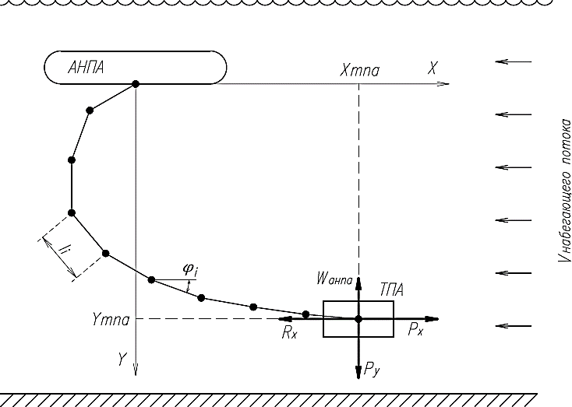
The cable in this model is approximated by a sequence of rods connected by hinges. It is believed that the hydrodynamic and mass-dimensional parameters of each rod are known. The calculation scheme is shown in Fig. 1. The angles of inclination of the i-th rod φi with respect to the horizontal plane are chosen as generalized coordinates.

Fig.1. Calculation scheme for software development
Based on this model, the Bauman Moscow State Technical University has developed a program that calculates cable reactions at the root and running section according to the specified propulsive thrusts and the specified cable length and determines the coordinates of the running end and, accordingly, the coordinates of the ROV.
However, the inverse problem is of interest: choosing the length of the cable and calculating the forces (propulsive thrusts) according to a given position of the ROV relative to the AUV. Calculation of specified propulsive thrusts is necessary for a preliminary assessment of the possibility of implementing such a position with a given configuration of the propulsion and steering complex.
To solve this problem, a new software has been developed, which has the following capabilities:
  - calculation of the configuration of a HUV cable in three-dimensional space for a given position of the ROV relative to the AUV;

  - selection of cable length and propulsive thrusts for a given position of the ROV relative to the AUV;
  - numerical and graphical representation of the calculation results. When developing the software, a number of assumptions were used:
  - the cable has a significant impact only on the ROV;
  - the external current acts along the longitudinal axis;
– the point of attachment of the cable to the ROV coincides with its center of mass;
  - the mass and dimensional characteristics of AUV and ROV are not taken into account, their angular or linear motion is not considered;
    - the cable is approximated by absolutely rigid rods;
    - the cable links are connected by spherical hinges, the first hinge is the hinge located on the AUV, the last hinge is on the ROV;
    - hydrodynamic forces, gravity and Archimedes' force, which act on the cable link, are applied to its middle;
– when considering the equilibrium condition of the cable links, it is considered that the orientation of the i-th link is completely determined by the forces that are applied to the (i-1) hinge; forces applied to the link itself are not taken into account; hydrodynamic forces of the i-th link, as well as its gravity and Archimedes are taken into account when determining the orientation of the next (i + 1) link.

The list of data and calculation results required for the calculation is given in Table 1.

1. Initial and output data of software
Initial data | Output data
- ROV coordinates  - coordinates of AUV  - maximum allowable cable tension  - cable parameters (diameter, linear mass, breaking force, maximum length - indicated based on the possibilities of placing the cable coil on the AUV)  - environmental parameters (flow velocity, water density, etc.)  - accuracy parameters (permissible coordinate error, the step of changing the length of the  cable, the step of changing the stops of the ROV | - calculated coordinates of the ROV  - recommended cable length  - the magnitude of the force arising in the  cable  - stops of the ROV propulsion units at which this position is reached  - errors of the coordinates of the ROV  - graphical representation of the cable configuration

1. Initial and output data of software
Initial data | Output data
movers)
Software development was carried out in the C++ programming language in the cross- platform development environment of Qt Creator.
For a visual representation of the simulation results, as well as to facilitate user interaction with the software, it was decided to implement a graphical interface. To create a graphical interface, built-in Qt tools were used, which made it possible to avoid connecting third-party libraries.
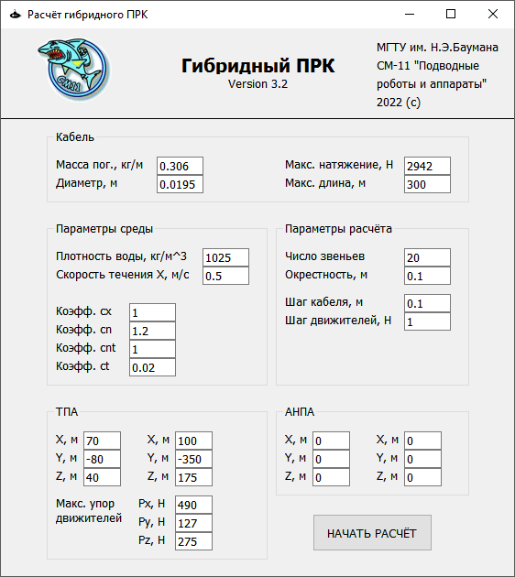
The appearance of the initial screen is shown in Figure 2.

Fig.2. The initial software window for modeling the configurations of the HUV cable
The user is asked to enter the necessary initial data or continue working with the default values.
The following data are used as default values:
- parameters of the cable [9] selected as an example of a cable with neutral buoyancy;
- the propulsive thrusts of the Falcon ROV [8], selected as an example of a small-sized
ROV.
The result of the software operation is displayed in a separate window, the appearance of
which is shown in Fig. 3.

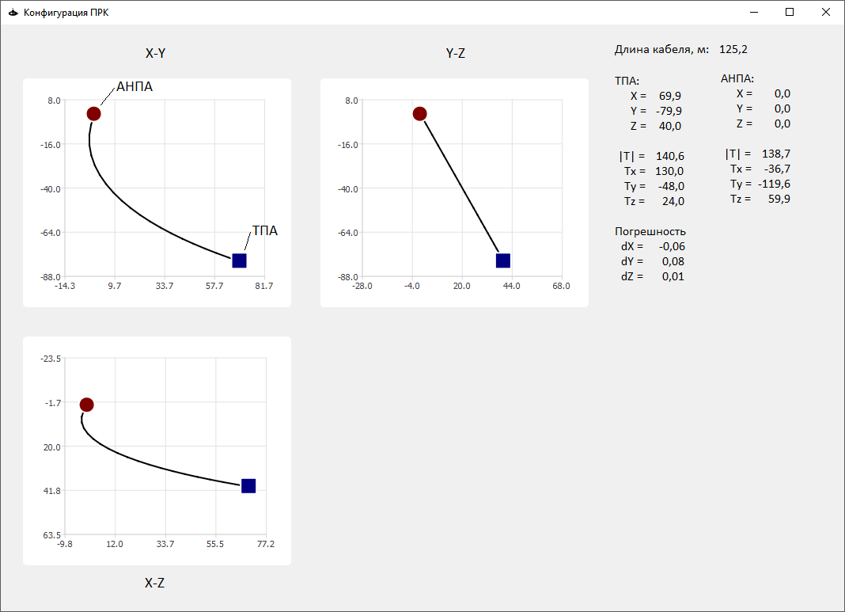
Fig.3. A window with HUV cable simulation results
The simulation results in Fig. 3 correspond to the initial data indicated on the initial screen (see Fig. 2).
Numerical results (calculated values of the coordinates of the devices, the voltages in the cable and the recommended length of the cable itself) and a graphical representation of the cable configuration in the form of three projections on the XY, YZ and XZ planes are displayed on the screen.
Also, during the operation of the software, a log file is recorded, in which intermediate data on possible cable configurations that satisfy the original data are entered. This makes it possible to conduct a more in-depth analysis.

Conclusions
The developed software allows mathematical modeling of the static configuration of the cable between AUV and ROV as part of a HUV in three-dimensional space and is a tool for applied research of the characteristics of a HUV.
In the future, this software can be modified to simulate the movement of a HUV in various modes of operation.

References
- Alekseev Yu.K. Two-section deep-sea robotic systems and some perspectives of underwater robotics. Technical problems of the development of the World Ocean, 2019, No. 8, p. 159-166.

- Boreyko A.A., Matvienko Yu.V., Shcherbatyuk A.F. Trends and prospects for the development of autonomous unmanned underwater vehicles. Technical problems of the development of the World Ocean, 2019, No. 8, p. 4-5.
- Bykanova A.Yu., Kostenko V.V., Mikhailov D.N., Storozhenko V.A. Development of a software and hardware complex for measuring the motion parameters of the underwater tethered system «AUV - communication cable - buoy - repeater”. Technical problems of the development of the World Ocean, 2019, No. 8, p. 80-85.
- Veltishchev V.V., Aladysheva E.I. On increasing the functional efficiency of autonomous unmanned underwater vehicles. Perspective systems and management tasks: Materials of the XV All-Russian scientific and practical conference and XI youth school-seminar
«Control and information processing in technical systems», Nizhny Arkhyz, October 05–09, 2020. Rostov-on-Don: Southern Federal University, 2020, p. 77-85.
- Veltishchev V.V. Designing of propulsion systems for underwater vehicles: a tutorial. Moscow: Publishing house of MSTU im. N.E. Bauman, 2019. - 167p.
- Gribanova I.V. Status and development trends of underwater robotic means. Matrix of scientific knowledge, 2019, no. 5, p. 19–22.
- Matvienko Yu.V., Kostenko V.V., Shcherbatyuk A.F., Remezkov A.V. Development of the technological potential of autonomous unmanned underwater vehicles. Underwater research and robotics, 2020, no. 4(34), p. 4-14. DOI 10.37102/24094609.2020.34.4.001
- Jane’s. Jane’s Unmanned Maritime Vehicles and Systems Issue Four. Edited by Charles
Hollosi. Coulsdon: HIS Jane’s, August 2010.
- ROV «Super Gnom Pro» technical specifications. URL: http://geaco.eu/products/gnom/super-gnom-pro.htm (дата обращения: 30.01.2020).

Veltishchev Vadim Victorovich — Doctor of Science (Eng.), Head of the Department
«Underwater Robots and Vehicles». Bauman Moscow State Technical University E-mail: vvv@bmstu.ru
Aladysheva Elena Igorevna — Postgraduate, Department «Underwater Robots and Vehicles». Bauman Moscow State Technical University
E-mail: aladysheva_elena@mail.ru

УДК 629.58 (681.516.42)
Gavrilina E.A., Chestnov V.N.

Synthesis of an attitude control system for highly maneuverable underwater vehicle using H-infinity approach

Recently tasks that require increased maneuverability of uninhabited underwater vehicles (operability at any orientation angles) become more frequent. However, the methodology for design control systems for such vehicles has not been sufficiently developed. The article analyzes the stability of the system, on the basis of which an approach to the construction of a control system using the decomposition algorithm and H∞ - synthesis of a control system for a separate channel is proposed. The operability of the approach is confirmed by the results of simulation on the full nonlinear model of the unmanned underwater vehicle "Aqua MO" and has a better quality in comparison with the traditional controller.
Keywords: highly maneuverable unmanned underwater vehicles, underwater robots, autonomous
unmanned underwater vehicles, attitude control system, H∞ - synthesis, robust control systems.

Introduction
Traditionally uninhabited underwater vehicles (UUVs) are operated at low angles of inclination (trim and roll). However, the scope of the UUV is expanding, new tasks and requirements are emerging. So, when conducting mine operations [1], a remote-controlled UUV (RCUUV) works with objects located on the bottom, walls, access to which may be difficult due to terrain features, the presence of underwater structures. To solve the problems, it is necessary to work from a close distance, which is possible with a large inclination of the UUV along the trim.
Another example is the docking of a hybrid UUV (equipped with a hybrid propulsion system) with a ship hull or other working surface. Hybrid UUVs are effective in solving the problems of flaw detection, inspection of underwater structures [2], [3]. The propulsion system of such UUVs makes it possible to control movement in the water due to propeller-driven units, and movement along the working surface due to an additional propulsion system based on tracks or wheels. One of the stages of operation of such a RCUUV is docking with the working surface, for which the RCUUV is deployed at a large trim or roll angle. On fig. 1, the docking process is illustrated by the example of the “Iznos” RCUUV developed at the Bauman Moscow State Technical University. [2].

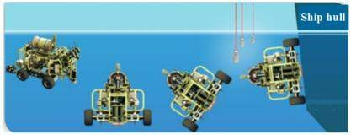
Fig. 1.The process of docking of RCUUV "Iznos" with the ship's hull
In addition, controllability in the entire range of orientation angles is necessary for UUVs working in conditions of limited space (caves, tunnels, ports). For example, the autonomous uninhabited underwater vehicle (AUUV) UX-1 [4] was designed to survey and map the tunnels of old flooded mines. Control with a large trim angle is used to move through vertical tunnels. AUUV SUNFISH [5] is designed to survey underwater caves. Increased maneuverability is necessary to work in a confined space, and is also used for the free orientation of sensors (hydroacoustic vision system, video cameras, etc.), which contributes to the effective solution of the SLAM problem. Other examples of highly maneuverable UUVs are presented in [6], [7]. Control at high inclinations is used to perform contact work, as well as rapid immersion of the AUUV.
The solution of these tasks using traditional UUV (with small angles of inclination) will require equipping the UUV with rotary devices for vision systems (cameras, sonar devices) or duplicating sensors; complicating the designs of manipulators or duplicating them; reducing the dimensions of the UUV. Duplication of devices, complication of the design of manipulators will lead to an increase in the cost of the UUV and its dimensions. Reducing the dimensions to increase maneuverability reduces the permissible capacity of AUUV batteries. At the same time, controllability in the entire range of orientation angles gives additional advantages: it allows you to work in a confined space, increases maneuverability, to freely orient sensors, tools, expands the working area of the manipulator and to perform contact operations with objects located at an angle (ship hull, bottom objects, etc.). Thus, the most effective solution is the development of new highly maneuverable UUV controlled in the entire range of orientation angles.
However, the control system of such UUVs should provide the required quality in the entire range of orientation angles. At the same time, at the moment, the issue of building a control system for an increased maneuverability is not sufficiently developed. In [5], [8], control systems are built on the basis of quaternions. At the same time, the modes of movement of the UUV at large inclination angles (for example, turns along the course at trim angles of more than 45°) are not studied in the works, and the dynamics of the propulsors are not taken into account in the analysis. The development of a control system for large angles and its full-scale tests were carried out in [5]. However, the paper considered a particular problem of the operation of a

highly maneuverable UUV when the trim angle is 90°, and did not consider movement with a non-zero inclination of the UUV along the roll or trim angles less than 90 °.
Currently, the issue of the operability of traditional orientation systems using Euler-Krylov angles at large inclination angles has not been sufficiently investigated, although the solution to this problem is practically significant, since it will allow using the accumulated experience and expanding the working angles of existing UUVs. The main reason for the refusal to use Euler angles is the presence of a special point (at a trim of ±90°), in which kinematic equations degenerate and the problem of ambiguity in the description of orientation appears (the course is indistinguishable from the roll) [9]. However, at the moment, algorithms have been developed that will allow to circumvent the disadvantages of Euler angles [10], [11], which increases interest in the refinement of the traditional control system for the tasks of highly maneuverable UUVs.
The operation of the traditional control system at large inclination angles was investigated in [12]. The paper shows that with an increase in the angles of trim and roll, the quality of the traditional control system deteriorates: mutual influences between channels increase, dynamic errors appear. At the same time, the roll channel is most affected by other channels. The dynamic error in the course of field experiments [3] reached 50°. A decomposition algorithm is proposed to solve the problem. The operability of the approach was confirmed during field experiments on the UUV "Iznos" [3] (the dynamic error was reduced to 5°). However, the stability of the system has not been investigated, and due to the inaccuracy of determining the parameters of the decomposition algorithm, residual interactions are observed in the system. Thus, for the further development of the methodology for constructing a control system for a highly maneuverable UUV, the question arises of developing an approach to the synthesis of a control system for separate channels of course, trim and roll, providing low sensitivity to disturbances from other channels, as well as the study of the stability of the system.
In this paper, the stability of the initial and decomposed system is investigated in accordance with the generalized Nyquist criterion [13]. Synthesis of regulators of separate channels is considered as an H∞-optimization problem designed in such a way that the resulting control system has low sensitivity to disturbances from other channels and has sufficient stability reserves. Verification of the results is carried out by mathematical modeling methods on a full nonlinear model of the Aqua MO AUUV [12]. The results of the algorithm are compared with the traditional controller.
The work is structured as follows. Section 1 presents the equations of the mathematical model of the UUV. In section 2, a study of the stability of the traditional management system is carried out. In section 3, the problem of synthesis of a roll control system using the H∞-approach

is solved. The results of an experimental study of the obtained approach on a complete nonlinear mathematical model of the UUV are given in Section 4.

Mathematical model
The mathematical model should qualitatively reflect the features of the UUV as an object of management, while remaining applicable for analytical research. In this paper, a complete nonlinear model of the UUV is used for modeling based on the works [12], [14]. The nonlinear model is linearized for the worst conditions in terms of stability and is used for synthesis and analysis. The mathematical model of the UUV includes a model of kinematics, dynamics and propulsors.
The orientation of the UUV is described as the position of the 𝑂𝑥𝑦𝑧 coordinate system associated with the device relative to the base coordinate system. The intermediate coordinate system 𝑂𝑥_{𝑔}𝑦_{𝑔}𝑧_{𝑔} is chosen as the base coordinate system, the center of which coincides with the pole of the device. It moves with the UUV, but does not change the direction of its axes. The pole of the 𝑂𝑥𝑦𝑧 coordinate system associated with the UUV also coincides with the pole of the UUV, the 𝑂𝑥 axis is directed along the longitudinal axis to the head of the device, the 𝑂𝑦 axis lies in the diametrical plane and is directed upwards, the 𝑂𝑧 axis is directed to the starboard side. Traditionally, the orientation of the UUV is described by three consecutive rotations of the 𝑂𝑥𝑦𝑧 coordinate system to the Euler-Krylov angles: course 𝜓 (around the 𝑂𝑦_{𝑔} axis), trim ϑ (around the intermediate position of the 𝑂𝑧 axis) and roll γ (around the 𝑂𝑥 axis) relative to the semi- connected 𝑂𝑥_{𝑔}𝑦_{𝑔}𝑧_{𝑔} coordinate system.
The kinematic equations of motion of the UUV are given by the Euler equations:

 | 𝜂̇ = 𝑃(𝜗, 𝛾)𝜈,  cos 𝛾 sin 𝛾  0 −  𝑃(𝜗, 𝛾) = [ cos ϑ cos ϑ ]  - sin 𝛾 cos 𝛾  - − tan 𝜗 cos 𝛾 tan 𝜗 sin 𝛾 | (1)
where ̇ ̇ 𝑇 is the vector of angular velocities along the course, trim and roll,
𝜂̇ = [ 𝜓 𝜗 𝛾̇ ]
𝑇

respectively, 𝜈 = [𝜔_{𝑥}
𝜔_{𝑦}
𝜔_{𝑧}] is the vector of angular velocities of rotation of the UUV around

the axes 𝑂𝑥, 𝑂𝑦, 𝑂𝑧; Р(𝜗, 𝛾) is the matrix of kinematic equations in Euler-Krylov angles.
The UUV dynamics model is considered for low speeds. The nonlinear model is described in [14] and has the following form:

 | 𝑀𝜈̇ + 𝐶(𝜈)𝜈 + 𝐷(𝜈)𝜈 + 𝑔(𝜂) = 𝜏 + 𝑤′ | (2)

where 𝑀 = 𝑑𝑖𝑎𝑔{𝐽_{𝑥} + 𝜆₄₄, 𝐽_{𝑦} + 𝜆₅₅, 𝐽_{𝑧} + 𝜆₆₆} is the matrix of mass-inertial characteristics of the UUV and the attached fluid; 𝐽_{𝑥}, 𝐽_{𝑦}, 𝐽_{𝑧} are moments of inertia, and 𝜆₄₄, 𝜆₅₅, 𝜆₆₆ are the attached moments of inertia of the UUV relative to the axes 𝑂𝑥, 𝑂𝑦, 𝑂𝑧, respectively; 𝜈̇ =
𝑇
[ 𝜔_{𝑥}̇ , 𝜔_{𝑦}̇ , 𝜔_{𝑧}̇ ] is the vector of angular accelerations of the UUV in the coordinate system 𝑂𝑥𝑦𝑧;
(𝜈) = −𝑑𝑖𝑎𝑔 { 𝐶_{𝜔}𝑥 + 𝐶_{𝜔}𝑥|𝜔𝑥||𝜔_{𝑥}|, 𝐶_{𝜔}𝑦 + 𝐶_{𝜔}𝑦|𝜔𝑦||𝜔_{𝑦}|, 𝐶_{𝜔}𝑧 + 𝐶_{𝜔}𝑧|𝜔𝑧||𝜔_{𝑧}|} is the matrix of hydrodynamic drag forces; 𝐶_{𝜔}𝑥 , 𝐶_{𝜔}𝑥|𝜔𝑥|, 𝐶_{𝜔}𝑦 , 𝐶_{𝜔}𝑦|𝜔𝑦|, 𝐶_{𝜔}𝑧 , 𝐶_{𝜔}𝑧|𝜔𝑧| are the coefficients of the hydrodynamic resistance to the rotational movement of UUV around the axes 𝑂𝑥, 𝑂𝑦, 𝑂𝑧, respectively; 𝑔(𝜂) is a vector of moments of the hydrostatic forces acting on UUV; 𝜏 =
𝑇
[𝜏_{𝑥} 𝜏_{𝑦} 𝜏_{𝑧}] is a vector of moments generated propulsion and steering complex; 𝑤′ =
[𝑤′_{𝑥} 𝑤′_{𝑦} 𝑤′_{𝑧}] is a vector of moments caused by external disturbances, which act on UUV; 𝐶(𝜈) is the matrix of highlights from the centrifugal force of inertia and Coriolis forces of inertia, which has the form:
𝑇

 | 𝐶(𝜈) |  |  | (3)
 | 0 | −(𝐼_{𝑧} + 𝜆₆₆)𝜔_{𝑧} | (𝜆₅₅ + 𝐼_{𝑦})𝜔_{𝑦}
 | = [ (𝜆₆₆ + 𝐼_{𝑧})𝜔_{𝑧} | 0 | −(𝐼_{𝑥} + 𝜆₄₄)𝜔_{𝑥}]
 | −(𝐼_{𝑦} + 𝜆₅₅)𝜔_{𝑦} | (𝜆₄₄ + 𝐼_{𝑥})𝜔_{𝑥} | 0
Based on the requirements for the design of highly maneuverable UUVs - the combination of the center of mass and the center of displacement, in order to reduce to zero the influence of hydrostatic moments 𝑔(𝜂), to simplify the analysis, we assume a metacentric height of zero.
We will linearize equation (2) for the worst case from the point of view of stability (when
𝜔_{𝑥} = 𝜔_{𝑦} = 𝜔_{𝑧} = 0). We transform the obtained Laplace equations and obtain the following transfer functions of the rotational motion of the UUV, which we will use in the synthesis:

 | 𝜔_{𝑗}(𝑠) 𝐾_{па𝑗}  𝑊_{па𝑗}(𝑠) = 𝜏 (𝑠) = 𝑇 𝑠 + 1 , 𝑗 = 𝑥, 𝑦, 𝑧  𝑗 па𝑗 | (4)

where 𝐾_{па𝑗}
= 1
𝐶𝜔𝑗1
, 𝑇па𝑗
= 𝐼𝑗+𝜆𝑘
𝐶𝜔𝑗1
is the amplification factor and the time constant of the

transfer function of the dynamics of rotational motion of the UUV.
In accordance with the work [14], the dynamics of a propeller-driven unit (a propulsion device based on a propeller) can be described by an aperiodic link of the first order:
 | 𝜏_{𝑗}(𝑠) 𝐾_{дв𝑗}  𝑊_{дв𝑗}(𝑠) = 𝑈 (𝑠) = 𝑇 𝑠 + 1 , 𝑗 = 𝑥, 𝑦, 𝑧  𝑗 дв𝑗 | (5)

where 𝑈_{𝑗} is the voltage applied to the motor; 𝐾_{дв𝑗} is the gain, 𝑇_{дв𝑗} is the time constant of the unit.
A mathematical model of UUV dynamics for further research can be written as follows:

 | 𝜔_{𝑗}(𝑠)  𝑊_{𝑗}(𝑠) = 𝑈 (𝑠) = 𝑊_{дв𝑗}(𝑠)𝑊_{па𝑗}(𝑠), 𝑗 = 𝑥, 𝑦, 𝑧  𝑗 | (6)

Stability analysis
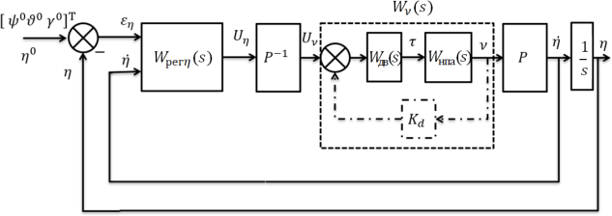
There are two known approaches to the construction of a control system for the orientation of the UUV: an approach with damping velocity coupling by angular velocity 𝜂̇ along the course, trim and roll (a system of the first type) [14], [15], an approach with damping feedback by the angular velocity vector 𝜈 relative to the axes associated with the UUV (a system of the second type) [7]. A generalized block diagram suitable for describing each of the approaches is shown in Fig. 2.
Fig. 2. Block diagram of the UUV orientation control system

The mismatch between the set and current values for the course, trim and roll, given by the vector 𝜀 = [𝜀 , 𝜀 , 𝜀 ]𝑇, and the current angular velocities 𝜂̇ = [𝜓̇ 𝜗̇ 𝛾̇]𝑇 are supplied to the regulators of the separate channels for controlling the course, trim and roll of the UUV, represented by the matrix 𝑊_{𝑟𝑒𝑔𝜂}(𝑠).
𝜂 𝜓 𝜗 𝛾
𝑇

The generated control signals of the course, trim and roll control channels 𝑈_{𝜂}
𝑇
= [𝑈_{𝜓}
𝑈_{𝜗}
𝑈_{𝛾}
] are

converted into control signals U_{ν}
= [𝑈_{𝑥}
𝑈_{𝑦}
𝑈_{𝑧}] relative to the coordinate system associated

with the UUV. In this case, the matrix 𝑃⁻¹(𝜗, 𝛾) is used, which is inverse to the matrix 𝑃(𝜗, 𝛾), presented in (1). The control signals are fed into the local control loop of the angular velocity or are fed to the UUV propulsion and steering system. The control law, in accordance with which control signals to the propulsion complex are generated, has the form:

 | 𝑈_{𝜈} | = 𝑃⁻¹(𝜗, 𝛾)𝑊_{рег𝜂} | (𝑝)[ 𝜀_{𝜂} | 𝑇  𝜂̇] − 𝐾_{𝑑𝜈} | 𝑠𝑖𝑛(𝜗)  𝜈, 𝑃⁻¹(𝜗, 𝛾) = [ 𝑐𝑜𝑠(𝛾) 𝑐𝑜𝑠(𝜗) | 0  𝑠𝑖𝑛(𝛾) | 1  0], | (7)
 |  |  |  |  | − 𝑠𝑖𝑛(𝛾) 𝑐𝑜𝑠(𝜗) | 𝑐𝑜𝑠(𝛾) | 0
where 𝑊_{рег𝜂}(𝑠) = [𝑊_{рег𝜂1}(𝑠) 𝑊_{рег𝜂2}(𝑠)], 𝑊_{рег𝜂1}(𝑠) =
𝑑𝑖𝑎𝑔 { 𝑊_{рег𝜓1}(𝑠) 𝑊_{рег𝜗1}(𝑠) 𝑊_{рег𝛾1}(𝑠) } - functions of position feedback controllers,
𝑊_{рег𝜂2}(𝑠) = 𝑑𝑖𝑎𝑔 {𝑊_{рег𝜓2}(𝑠) 𝑊_{рег𝜗2}(𝑠) 𝑊_{рег𝛾2}(𝑠)} и 𝐾_{𝑑} = 𝑑𝑖𝑎𝑔 {𝐾_{𝑑𝑥} 𝐾_{𝑑𝑦} 𝐾_{𝑑𝑧}} are speed feedback controllers for the vectors 𝜂̇ ̇ and ν, respectively. In the case of a system of the first type, the damping velocity connection is carried out along the vector of angular velocities 𝜂̇, i.e.
𝑊_{рег𝜂2} ≠ 0_{3×3}, 𝐾_{𝑑𝜈} = 0_{3×3}. For a system of the second type, the damping velocity connection is
carried out due to the vector of angular velocities ν, i.e. 𝐾_{𝑑} ≠ 0_{3×3}, 𝑊_{рег𝜂2} = 0_{3×3}. In [12], the transfer matrix W(s) of an open-loop system for the second case was obtained, which has the following form:

 | 𝜂 = 1 𝑃(𝜗, 𝛾)𝑊 (𝑠)𝑃⁻¹(𝜗, 𝛾)𝑊 (𝑠)𝜀 = 1 𝑊(𝑠)𝜀 ,  𝑠 𝜈 рег.𝜂1 𝜂 𝑠 𝜂  𝑊(𝑠)  𝑊 (𝑊 cos² γ + 𝑊 sin² γ) sin 2γ 𝑊 (𝑊 − 𝑊 ) 0  рег.ψ 𝑦 𝑧 рег.ϑ 𝑦 𝑧  2сosϑ  = 1 sin 2𝛾 cos 𝜗 𝑊 (𝑊 − 𝑊 ) 𝑊 (𝑊 cos² 𝛾 + 𝑊 sin² 𝛾) 0 ,  2 рег.𝜓 𝑦 𝑧 рег.ϑ 𝑧 𝑦  2 2 1 [sin ϑ 𝑊_{рег.ψ}(𝑊_{𝑥} − 𝑊_{𝑦} cos γ − 𝑊_{𝑧} sin γ) 2 sin 2𝛾 tan 𝜗 𝑊_{рег.ϑ}(𝑊_{𝑦} − 𝑊_{𝑧}) 𝑊_{рег.γ}𝑊_{𝑥}] | (8  )
where 𝑊_{𝜈}(𝑠) = 𝑑𝑖𝑎𝑔 {𝑊_{𝑥}(𝑠), 𝑊_{𝑦}(𝑠), 𝑊_{𝑧}(𝑠)}- is the transfer matrix of the part of the system that is located between the matrices 𝑃(𝜗, 𝛾) and 𝑃⁻¹(𝜗, 𝛾) (see Fig. 2), the transfer functions
𝑊_{𝑥}(𝑠), 𝑊_{𝑦}(𝑠), 𝑊_{𝑧}(𝑠) are calculated in accordance with (6) if 𝐾_{𝑑𝜈} = 0_{3×3}; 𝑊_{рег.𝛼}(𝑠) =
𝑊_{рег.𝛼1}(𝑠), 𝛼 = 𝜓, 𝜗, 𝛾 are the transfer functions of the regulator.
Despite the fact that the transfer function W(s) is obtained for the system of the second type, it can be used to analyze the stability of the system of the first type, in that case, if we take the nominal impact on the system is zero (see Fig. 3). Then the transfer function of the regulator should be calculated as follows:
 | 𝑊_{рег.α}(𝑠) = 𝑊_{рег.𝛼1}(𝑠) + 𝑠 𝑊_{рег𝛼2}(𝑠), 𝛼 = 𝜓, 𝜗, 𝛾 | (9)
Such a representation of the transfer function of the regulator in (8) will allow using expression (8) to analyze the stability of systems of both the first and second types.
The type of the transfer matrix W(s) allows us to conclude that the control system orientation of the UUV is multi-connected. With the growth of the angles of inclination, the following features appear:

- With an increase in the roll angle, the transfer functions of the diagonal elements of the transfer matrix of the system change.
- As the angle of the trim increases, the mutual influences between the channels increase.
- The roll contour is most susceptible to disturbing influences from other channels.

The structure of the control system, characterized by equations (8), is such that the application of any special techniques to the synthesis of separate channel controllers will not solve the problem of communication between channels. Therefore, in [12], it was proposed to use a decomposition algorithm that reduces the matrix W(s) presented in (8) to a diagonal form. For the decomposition of the system, the matrix 𝑃⁻¹ is replaced by the matrix 𝑃′⁻¹ of the following form:

 |  | 𝑊′𝑦(𝑠)  𝑠𝑖𝑛(𝜗) 𝑊′ (𝑠)  𝑥  𝑐𝑜𝑠(𝛾) 𝑐𝑜𝑠(𝜗)  − 𝑠𝑖𝑛(𝛾) 𝑐𝑜𝑠(𝜗) 𝑊′𝑦(𝑠) [ 𝑊′𝑧(𝑠) | 0 | 1 | (10)
 | 𝑃′⁻¹ = |  | sin(𝛾) 𝑊′𝑧(𝑠)  𝑊′𝑦(𝑠) | 0 ,
 |  |  | 𝑐𝑜𝑠(𝛾) | 0  ]
where 𝑊′_{𝑥}(𝑠), 𝑊′_{𝑦}(𝑠), 𝑊′_{𝑧}(𝑠) used in decompositum algorithm, transfer function, which is defined as the evaluation of the transfer functions 𝑊_{𝑥}(𝑠), 𝑊_{𝑦}(𝑠), 𝑊_{𝑧}(𝑠) of the UUV. When using the algorithm of decomposition of the transfer matrix W(s) takes the form:

 | 𝑊_{рег.ψ}(𝑠)𝑊₁₁(𝑠) | 𝑊_{рег.ϑ}(𝑠)𝑊₁₂(𝑠) | 0 |  | (11)
 | 𝑊(𝑠) = [𝑊_{рег.ψ}(𝑠)𝑊₂₁(𝑠) | 𝑊_{рег.ϑ}(𝑠)𝑊₂₂(𝑠) | 0 | ],
 | 𝑊_{рег.ψ}(𝑠)𝑊₃₁(𝑠) | 𝑊_{рег.ϑ}(𝑠)𝑊₃₂(𝑠) | 𝑊_{рег.γ}(𝑠)𝑊_{𝑥}(𝑠)

where ( )
2( )
𝑊𝑧(𝑠)𝑊′(𝑠)

²( ) ;
( ) sin(2𝛾) (𝑊 (𝑠)𝑊 ′(𝑠)

); ( )

𝑊 𝑠
= (𝑊 (𝑠) cos
𝛾 +
^{𝑦} sin
𝛾 )
𝑊 𝑠 =
𝑦 𝑧
− 𝑊 (𝑠)
𝑊 𝑠 =

11 𝑦
𝑊′(𝑠)
12 2 cos(ϑ)
𝑊𝑦′(𝑠) 𝑧 21

sin(2𝛾) (𝑊𝑦(𝑠)𝑊𝑧′(𝑠) − 𝑊 (𝑠));
𝑧

(𝑠) = 𝑊 cos²(𝛾) + 𝑊𝑦(𝑠)𝑊𝑧′(𝑠) sin²(𝛾);

( ) ( )
𝑊𝑥(𝑠)𝑊𝑦′(𝑠) −

2 cos(ϑ)
𝑊𝑦′(𝑠) 𝑧
22 𝑧
𝑊𝑦′(𝑠)
𝑊₃₁ 𝑠
= sin 𝜗 (
𝑊𝑥′(𝑠)

(𝑊 (𝑠) cos²(𝛾) + 𝑊𝑧(𝑠)𝑊𝑦′(𝑠) sin²(𝛾)));
( ) ¹

( ) ( ) (
𝑊𝑦(𝑠)𝑊𝑧′(𝑠)).

𝑦 𝑊𝑧′(𝑠)
𝑊₃₂ 𝑠
= sin 2𝛾
2
tg ϑ
𝑊_{𝑧}(𝑠) −
𝑊𝑦′(𝑠)

If the parameters of the decomposing algorithm are precisely defined, i.e. 𝑊′_{𝑥}(𝑠) =
𝑊_{𝑥}(𝑠), 𝑊′_{𝑦}(𝑠) = 𝑊_{𝑦}(𝑠), 𝑊′_{𝑧}(𝑠) = 𝑊_{𝑧}(𝑠), then the transfer matrix (11) takes a diagonal form, and the course, trim and roll control channels become independent of each other. If the parameters are determined inaccurately, then the conclusions drawn for the transfer matrix of the original system (8) are valid for the transfer matrix of the decomposed system. Of the transfer matrix (11) we can obtain the transfer matrix of the original system (8), if you set the parameters of the algorithm decomposing a single value:

 | 𝑊′_{𝑥}(𝑝) = 𝑊′_{𝑦}(𝑝) = 𝑊′_{𝑧}(𝑝) = 1 | (12)

To analyze the stability of the UUV orientation control system, consider a scheme with zero preset values, which is shown in Figure 3. This scheme is suitable for analyzing the stability of control systems of both the first and second types.

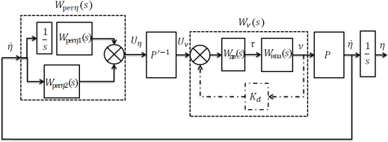
Fig. 3. Scheme for stability analysis

We use the necessary and sufficient conditions for the stability of the UUV orientation control system according to the Nyquist criterion, in accordance with the theorem given in [13]. To analyze the stability of the system, it is necessary to obtain expressions for the eigenvalues
𝜆_{𝑖}(𝑠) of the transfer matrix W(s). Since, if condition (12) is satisfied, the transfer matrix of the decomposed system can be obtained from the transfer matrix of the original system, the analysis of matrix (11) will allow us to find the stability conditions of both the decomposed and undecomposed system.
The eigenvalues 𝜆_{𝑖}(𝑠) of the transfer matrix (11) are found from the equation:

 | det[𝜆𝐸_{𝑚} − 𝑊(𝑠)] = 0 | (13)
The characteristic equation of the system will take the form:

 | 𝜆(𝑠) 𝑊 ′(s) 𝑊′(s)  [𝜆²(s) − (𝑠𝑖𝑛²(𝛾) (𝑊 (s) − 𝑧 𝑊 (𝑠)) ( 𝑦 𝑊 (s) − 𝑊 (𝑠))  𝑠 𝑧 𝑊′(s) 𝑦 𝑊′(s) рег.𝜓 рег𝜗  𝑦 𝑧  + 𝑊_{𝑦}(𝑠)𝑊_{рег𝜓}(s) + 𝑊_{𝑧}(𝑠)𝑊_{рег𝜗}(𝑠))  1 1  + 𝑠2 𝑊_{рег.ϑ}(𝑠)𝑊_{рег.ψ}(𝑠)𝑊_{𝑧}(𝑠)𝑊_{𝑦}(𝑠)] [𝜆(𝑠) − 𝑠 𝑊_{рег.γ}(𝑠)𝑊_{𝑥}(𝑠)] = 0 | (14
 |  | )
The eigenvalues of the matrix can be found using the equations:

 | 1  𝜆_{1,2}(s) = (𝑊(𝑠) ± √𝑊(𝑠)² − 4𝑊_{рег𝜓}(𝑠)𝑊_{рег𝜗}(𝑠)𝑊_{𝑧}(𝑠)𝑊_{𝑦}(𝑠)) , 2𝑠  𝜆 (s) = 1 𝑊 (𝑠)𝑊 (𝑠),  { 3 𝑠 рег𝛾 𝑥 | (15)

where
2( )
( ) 𝑊′𝑧(𝑠) ( )

𝑦
𝑊′𝑦(𝑠) ( ) ( )

𝑧

𝑊(𝑠) = 𝑠𝑖𝑛
𝛾 (𝑊_{𝑧} s
− 𝑊′
(𝑠) 𝑊𝑦
𝑠 ) (𝑊′ (𝑠) 𝑊рег.𝜓 s
− 𝑊рег𝜗
𝑠 ) +

𝑊_{𝑦}(𝑠)𝑊_{рег𝜓}(s) + 𝑊_{𝑧}(𝑠)𝑊_{рег𝜗}(𝑠), and 𝜗 ≠ ±90⁰.
The following conclusions can be drawn from the equations for determining eigenvalues.
The eigenvalue 𝜆₃ corresponding to the roll control channel does not depend on the angles of inclination of the UUV. Consequently, the synthesis of the roll control channel can be carried out independently of the course and trim channels.
A pair of eigenvalues 𝜆_{1,2} corresponding to the course and trim control channels, in general, does not depend on the inclination of the UUV in the angle of the trim, but depends on the inclination of the UUV in the roll.
In the case of an undecomposed system, a pair of eigenvalues 𝜆_{1,2} does not depend on the roll angle, if the transfer functions of the rotation of the UUV around the axes 𝑂𝑦, 𝑂𝑧 or the transfer functions of the regulators at the course 𝑊_{рег.𝜓} and the difference 𝑊_{рег𝜗} coincide,
i.e. 𝑊_{𝑦}(𝑠) = 𝑊_{𝑧}(𝑠) or 𝑊_{рег.𝜓}(𝑠) = 𝑊_{рег𝜗}(𝑠) and at the same time the stability conditions of the separate course and trim control channels are satisfied.
If the elements of the decomposing algorithm 𝑊′(𝑠), 𝑊 ′(𝑠) are precisely defined, then
𝑦 𝑧
the stability of the system depends only on the stability of the separate channels of the course, trim and roll. The accuracy of determining 𝑊′(𝑠) does not affect the stability of the system.
𝑥
In the case of inaccurate determination of the parameters of the decomposing algorithm, the roll remains the channel most affected by the control actions on the course and trim. At the same time, with an increase in the roll angle, the stability conditions of the course and trim control channels change.

An approach to the synthesis of a separate channel
One of the main requirements for a separate channel is low sensitivity to disturbing influences from other channels. For the successful implementation of the obtained control laws in practice, it is necessary that the constructed control system has sufficient reserves of stability in phase and amplitude. One of the most common ways to solve such problems is to use the H∞ approach to the synthesis of regulators [16].
The equations of the linearized channel in the standard form for the case when the angles of inclination along the trim and roll are zero can be written as follows:
 | 𝑥̇ = 𝐴𝑥 + 𝐵₁𝑤 + 𝐵₂𝑢_{𝑥} | (16)

𝑦 = 𝐶𝑥
0 1 0 0 0
−𝐶𝜔𝑖1 1
𝐴 = 0 𝐼𝑖+𝜆𝑗𝑗 𝐼𝑖+𝜆𝑗𝑗 , 𝐵 = [ 0 ], 𝐵 = [ 0 ], 𝐶 = 1 0 0 ],
1 𝐾 дв𝑖 2 𝐾 дв𝑖 [
1 0 1 0
0 0 − 𝑇дв𝑖 𝑇дв𝑖
[ 𝑇дв𝑖]

where 𝑥 = [𝛼 𝛼̇ 𝜏_{𝑖}]^{𝑇} is the vector of UUV state variables, and 𝑖 = 𝑦, 𝑧, 𝑥 ; 𝛼 = 𝜓, 𝜗, 𝛾 – course, trim or roll angle, 𝑤 – external disturbance from other channels, reduced to the input of the UUV propulsion complex, 𝑢_{𝛼} – control voltage to the UUV propulsion complex, 𝑦 – vector of measured variables.
The equations of the desired controller have the form:

 | 𝑥̇_{𝑐} = 𝐴_{𝑐}𝑥_{𝑐} + 𝐵_{𝑐}𝑦  𝑢 = 𝐶_{𝑐}𝑥_{𝑐} + 𝐷_{𝑐}𝑦 | (17)
where 𝑥_{𝑐} is the state vector of the controller, the order of which does not exceed the order of the control object, the matrices 𝐴_{𝑐}, 𝐵_{𝑐}, 𝐶_{𝑐}, 𝐷_{𝑐} of the controller will be obtained when solving the problem of synthesis of CS.
The synthesis of the regulator will be carried out based on the following system requirements. The value of the dynamic error from the disturbing effects of other channels is limited by the value Δ_{𝛼} = 5⁰. The resulting system must have stability reserves of the main and high-speed circuits of at least 10 dB in amplitude ∆𝐿 and 42° in phase ∆𝜑. At the same time, the radius of stability reserves at points "a", "b", "c", marked in Fig. 4, should be at least 0.75. This refers to the stability margin of the system, the connection in which is open at one of the specified points of its scheme.

The block diagram used in the synthesis of the regulator is shown in Fig. 4. Four adjustable variables are introduced in the scheme: 𝑧₁ - orientation angle weighted by the coefficient 𝑄₁ (course, trim or roll), 𝑧₂ - angular velocity weighted by the coefficient 𝑄₂ (course, trim or roll),
𝑧₃ - the final control signal received at the input of the propulsion complex, 𝑧₄ - control signal generated by the regulators of the separate channel. These variables make up the vector of regulated variables 𝑧 = [𝑧₁ 𝑧₂ 𝑧₃ 𝑧₄]^{𝑇}.

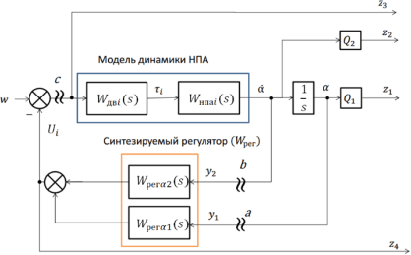

Fig. 4. Separate channel synthesis scheme

The disturbing action w is an effect from other channels. When solving the H∞ optimization problem, the norm of the transfer matrix 𝑇_{𝑧𝑤} of the system connecting the vector of controlled variables z with the external disturbing w is minimized. The transfer matrix 𝑇_{𝑧𝑤} has the following structure:
 | 𝑇  𝑧 = 𝑇_{𝑧𝑤}(𝑠)𝑤 = [𝑇_{𝑧}1𝑤(𝑠)𝑇_{𝑧}2𝑤(𝑠) 𝑇_{𝑧}3𝑤(𝑠) 𝑇_{𝑧}4𝑤(𝑠)] 𝑤 | (18)
As a result of solving the synthesis problem for the transfer matrix 𝑇_{𝑧𝑤}, and, hence, for its components 𝑇_{𝑧}1𝑤(𝑠), 𝑇_{𝑧}2𝑤(𝑠), 𝑇_{𝑧}3𝑤(𝑠), 𝑇_{𝑧}4𝑤(𝑠) the condition will be fulfilled:
 | ||𝑇_{𝑧𝑤̅}(𝑗𝜔)||∞ ≤ 𝛾′, | (19)
where γ' is a given or minimized parameter.
The fulfillment of condition (18) for transfer functions 𝑇_{𝑧}1𝑤(𝑠) 𝑇_{𝑧}2𝑤(𝑠) with the appropriate choice of weighting coefficients 𝑄₁, 𝑄₂ ensures low sensitivity of the system to disturbances from other channels, and for transfer functions 𝑇_{𝑧}1𝑤 (𝑠), 𝑇_{𝑧}2𝑤(𝑠), 𝑇_{𝑧}3𝑤(𝑠) - provides stability reserves of the system at points "a", "b", "c", marked in Fig. 4. Thus, the proposed formulation of the problem will make it possible to obtain a roll channel regulator that provides a small dynamic error when the channels work together and stability reserves sufficient for practical use of the regulator.
The equations of the generalized object for the problem under consideration are presented in standard form:
 | 𝑥̇ = А 𝑥 + 𝐵 [ 𝑤̅ ], | (20)
 | 𝑔 𝑔 𝑢𝑥
 | 𝑧 = 𝐶₁𝑥 + 𝐷₁₁𝑤̅ + 𝐷₁₂𝑢_{𝑥},
 | 𝑦 = 𝐶𝑥 + 𝐷₂₁𝑤̅ + 𝐷₂₂𝑢_{𝑥},
where the matrices of the generalized object have the form:

 | 𝐴 = 𝐴, 𝐵 = [ 𝐵 𝐵 ], , 𝐶 = 𝐶1], 𝐷 = [𝐷11 𝐷12], 𝐵 = 𝐵 = [0 0 𝐾дв 𝑇,  𝑔 𝑔 1 2 𝑔 [ 𝐶 𝑔 𝐷21 𝐷22 1 2 𝑇 ]  дв  𝑄₁ 0 0  𝐶₁ = [0 𝑄2 0],  0 0 0  0 0 0  𝐶 = [1 0 0  ], 𝐷₁₁ = [0 0 𝑄₃ 0]^{𝑇}, 𝐷₁₂ = [0 0 𝑄₃ 𝑄₄]^{𝑇}, 𝐷₂₁ = 𝐷₂₂ =  0 1 0  [01х4]𝑇 | (21)

Simulation results
The computational experiment was carried out on the nonlinear model of the UUV "AQUA-MO", the description of which is given in [12]. At the first stage, the synthesis of separate channels was carried out according to the proposed method. At the next stage, the operation of the control system was checked taking into account the decomposition algorithm for the worst conditions corresponding to a turn on the course (180°) with a large inclination along the trim (80°) and roll (45°). The test movement is similar to the one presented in [12], where the decomposition algorithm and the traditional regulator of the separate channel were also used. The quality of the obtained result is compared with the quality of the control system from the work [12].
In the synthesis of the controller, the Matlab package Robust Control Toolbox was used, using the technique of linear matrix inequalities (LMI). The weighting coefficients 𝑄₁, 𝑄₂ were assumed to be 200. The regulators obtained for the roll channel have the form:
W = 1.289∙108 (𝑝−3995) (𝑝+689) , W = 3.27∙109(𝑝+9261) (𝑝+11.62) .

рег𝛾1
(𝑝+2.089∙105) (𝑝+9297) (𝑝+1265)
рег𝛾2
(𝑝+2.089∙105) (𝑝+9297) (𝑝+1265)

For the course channel: W
= 2.0069∙106 (𝑝+3996)(𝑝+270.7), W =

рег𝜓1
(𝑝+26930)(𝑝+839.5) (𝑝+436.9)
рег𝜓2

1.1991∙108(𝑝+834.5) (𝑝+11.02) , and for the trim channel: W

= 65.327 (𝑝+2151) (𝑝+15.19), W =

(𝑝+26930)(𝑝+839.5) (𝑝+436.9)

5877(𝑝+21.21) (𝑝+10.09). (𝑝+521.7) (𝑝+20.64)
рег𝜗1
(𝑝+521.7) (𝑝+20.64)
рег𝜗2

The radii of stability reserves, phase and amplitude stability reserves in separate channels with synthesized regulators are shown in Table 1. The parameters are given for control systems open at points "a", "b", "c" (Fig. 4) and meet the specified requirements described in Section 4.

Parameters of separate channels
Channel | 𝛾′ | High-speed contour  (point "b") | Positional contour  (point "a") | Radii of stability  reserves

 |  | Δ𝐿, дБ dB | 𝜑,⁰ | Δ𝐿, дБ | 𝜑,⁰ | r_{c} | 𝑟_{𝑏} | r_{a}
Course | 1.0259 | 22.3 | 92.8 | 70.6 | 76.5 | 0.986 | 0.984 | 0.833
Trim | 1.0317 | ∞ | 89.3 | 25.3 | 79.2 | 0.982 | 0.981 | 0.866
Roll | 1.0595 | -24.5 | 84.5 | 36.2 | 84.5 | 0.968 | 0.968 | 0.931

Transient processes during the execution of the test movement are shown in fig. 5. They are aperiodic. The transient time does not exceed 3 seconds, and the dynamic error in the roll channel was 2°, while when using a traditional controller with a decomposition algorithm [12] it was 23°. That is, the dynamic error is reduced by ten times compared to the error when using a traditional controller.
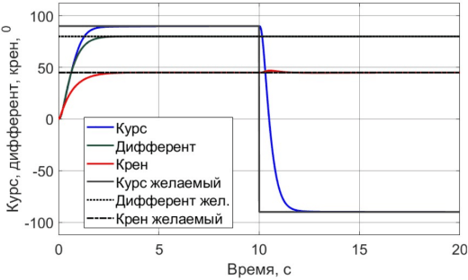
Fig. 5. Transients in the system during the test movement

Conclusion
In this paper, the stability condition of the UUV orientation control system is obtained for the traditional approach using Euler-Krylov angles for the initial system and the system with the decomposition algorithm [12]. The stability condition is not affected by the inclination of the UUV along the trim (for the case when 𝜗 ≠ 90⁰), however, the change in the roll affects. An approach to the synthesis of separate channels is proposed, which provides low sensitivity to disturbances from other channels and provides sufficient reserves of stability. The synthesis problem is solved using the H∞ - approach.
The simulation results showed that the proposed regulator reduced the dynamic error in the roll channel by 10 times compared to a system using a traditional regulator. At the same time, the resulting system has sufficient stability reserves (more than 22 dB in amplitude, more than 76 ° in phase). In addition, the resulting regulator has a low order and can be implemented in practice.

But the synthesized system has a limitation. It is inoperable when inclination along the trim angle is ±90°, which is of interest for further research.

References
- Reed S.E., Wood, J., and Haworth C. The detection and disposal of IED devices within harbor regions using AUVs, smart ROVs and data processing/fusion technology. 2010 International WaterSide Security Conference, 2010 p. 1-7
- Veltishev V.V. et al. Robotic technology for surveying the underwater part of the ship/
Veltishev V.V. // Underwater research and robotics. - 2016. - №1(21). - p.15-24.
- Gavrilina E.A., Chestnov V.N., Kropotov V.N. A Decomposition Algorithm for Attitude Control of the Remotely Operated Vehicle at Large Pitch and Roll Angles. 2019 18th European Control Conference (ECC), 2019, p. 3334-3339.
- Suarez Fernandez R.A. и др. Motion Control of Underwater Mine Explorer Robot UX-1: Field Trials. IEEE Access, vol. 7, 2019, p. 99782-99803.
- Richmond K., et al. SUNFISH®: A human-portable exploration AUV for complex 3D environments. OCEANS 2018 MTS/IEEE Charleston, 2018, p. 1-9.
- Sakagami N. et al. "Design and development of an attitude control system for a human-sized ROV," 2010 11th International Conference on Control Automation Robotics & Vision, 2010, p. 2141-2146.
- Ferreira B.M., Jouffroy J., Matos A.C., and Cruz N.A. Control and guidance of a hovering AUV pitching up or down. 2012 Oceans, 2012, p. 1-7.
- Fjellstad O. E. and Fossen T. I. Quaternion Feedback Regulation of Underwater Vehicles, Proceedings of the 3rd IEEE Conference on Control Applications, Vol. 2, 1994, p. 857-862.
- Matveev V.V., Raspopov V.Ya. Basics of building strapdown inertial navigation systems –
St.P..: “Concern "TsNII Elektropribor”, 2009. – 280
- Singla P., Mortari D. and Junkins J. How to avoid singularity when using Euler angles? Advances in the Astronautical Sciences, Vol. 119, 2005, p.1409-1426.
- Gavrilina E., Chestnov V. "Singularity-Free Attitude Control of the Unmanned Underwater Vehicle," 2020 24th International Conference on System Theory, Control and Computing (ICSTCC), 2020, p. 512-519, doi: 10.1109/ICSTCC50638.2020.9259733.
- Lyamina E.A., Egorov S.A. Features of constructing a control system for underwater vehicle angular orientation at large angles of inclination. Engineering Journal: Science and Innovation, 2018, Vol. 3. http://dx.doi.org/10.18698/2308-6033-2018-3-1745
- Desoer C. and Wang Y.T. On the generalized Nyquist stability criterion. IEEE Transactions on Automatic Control, Vol. 25, No. 2, 1980, p. 187-196.

- Fossen T.I. Marine Control Systems: Guidance, Navigation and Control of Ships, Rigs and Underwater Vehicles. Marine Cybernetics, Trondheim, Norway, 2020.
- Kostenko V.V., Michailov D.N. Development of the remotely operated vehicle "MAKS- 300". Underwater research and robotics, 2012, № 1 (13), P. 36–46.
- Chestnov V.N. Synthesis of Multivariable Systems According to Engineering Quality Criteria Based on H∞ Optimization. Automation and Remote Control, Vol. 80, 2019, p. 1861- 1877.

Gavrilina Ekaterina Andreevna - Assistant of the Department "Underwater Robots and Apparatuses" of Bauman Moscow State Technical University, e-mail: ekaterina.a.gavrilina@gmail.com
Vladimir Nikolaevich Chestnov - Doctor of Technical Sciences, Leading researcher of IPU RAS, e-mail: vnchest@yandex.ru

